
Second Sunday of Advent
December 7, 2014

Parish Advent Mission:
"Christ is Born"
Presented by Fr. Joseph Arledge,
December 6-10, 2014
The Mission will end Wednesday,
December 10 at 7 p.m. with
Advent Penance Service.
Schedule:
7 p.m., Monday, Immaculate Conception Mass
7 p.m., Tuesday, Assumption Church
7 p.m., Wednesday, Assumption, Penance Service
Mass Intentions / Peticiones de Misa

Sat | Dec 6 | 4:00p D | (+)Andrew Rodiger
 |  | 6:00p R | For the Good Health of Krystyna
Sun | Dec 7 | 8:00a M | (+)Kelly Hoegger
 |  | 10:00a D | (+)Pedro Martinez by  Alicia Martinez
 |  | 12:00p W | (+)Andrew Rodiger
 |  | 2:00p D | For the Parishioners
Mon | Dec 8 | 12:10p D | For the Good Health of Krystyna
 |  | 7:00p M | (+)Andrew Rodiger  Christmas Mass Schedule  Wednesday, December 24  6 p.m. Duncan Children's Mass  6 p.m. Walters  Midnight Mass in Duncan  Thursday, December 25  9 a.m. Marlow  11 a.m. Duncan  11 a.m. Ryan
Tues | Dec 9 | 12:10p D | (+)Pedro Martinez by Alicia Martinez and  (+)Andrew Rodiger
Wed | Dec 10 | 12:10p D | (+)Andrew Rodiger  And Int of Howard Doerr by The Wolfgang-Deeg Family
Thur | Dec 11 | 12:10p D | (+)Andrew Rodiger and  Int of Anna Fitts by  The Fitts Family
Fri | Dec 12 | 12:00 a D | Midnight - Guadalupe
 |  | 12:10p D | (+)Andrew Rodiger
Sat | Dec 13 | 4:00p D | (+)Andrew Rodiger  New Year's  Mass Schedule  Wednesday, December 31,  New Year's Eve  4 p.m. Ryan  6 p.m. Marlow  Thursday, Jan 1, New Year's Day  11 a.m. Duncan  1 p.m. Walters
 |  | 6:00p R | For the Parishioners
Sun | Dec 14 | 8:00a M | (+)Andrew Rodiger
 |  | 10:00a D | (+)Don Trostle and  (+)Jake Seratte
 |  | 12:00p W | (+)Andrew Rodiger
 |  | 2:00p D | (+)Leticia Sanchez
Baptismal Classes in English:
Sunday, December 14
after 8 a.m. Mass,
Immaculate Conception,
Marlow
presented by Deacon Jimmy Conway

Holiday Food Fund
There are envelopes in the pews
for our Catholic Food Bank.
Please be generous. God Bless you.

Upcoming Events:
Mon., Dec 8: Immaculate Conception Feast Day Mass, 12:10 pm in Duncan and 7 p.m. in Marlow.
Sat-Wed, Dec 6-10: Parish Advent Mission
Wed, Dec 10: 7 p.m. Penance Advent Service
Friday, Dec 12: Midnight, Our Lady of Guadalupe Mass
Wed., Dec 24: 6 p.m. Children's Mass

Christmas Decorating,
Monday, December 22
at 4 p.m.
Everyone is invited to come help
decorate our church for Christmas.
We will meet at 4 p.m.
The more people we have
the sooner we can get done!!!


Abuse of Minors Pastoral Response Hotline 405-720-987 or DHS at 1-800-522-3511. Línea Telefónica Pastoral para Reportar Abuso de Menores 405-720-9878 o el Departamento de Servicios Humanos al 1-800-522-3511.

You can have a Mass said for someone's intentions at their birthday, wedding, baptism, or in memory of your deceased loved ones. Contact he office for days and times that you wish to have the Mass celebrated. What a precious gift!

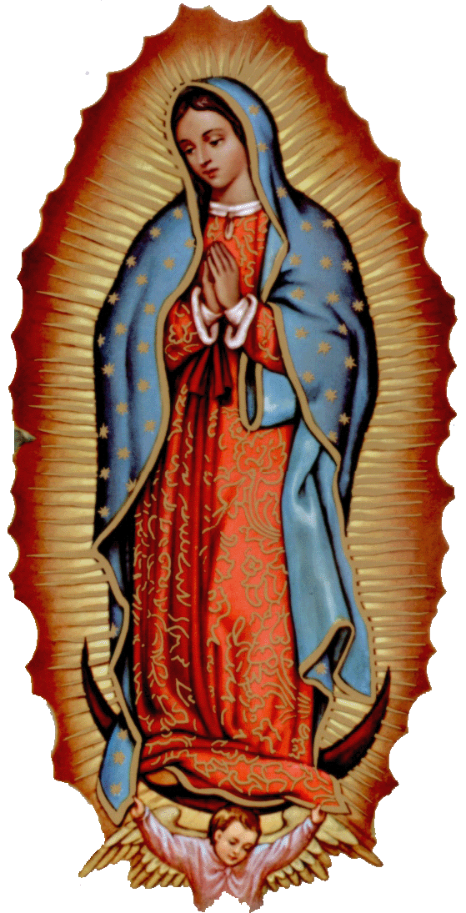
Our lady of Guadalupe celebration

Everyone is invited to the annual celebration
of the Virgin of Guadalupe.

Thursday, December 11
10:00pm ---------------------- Procession
11:00pm ---------------------- Matachines
(Traditional dancers)
Two Talks
Mañanitas
(Songs to Mary)
12 midnight ----------------- Mass
After Mass ------------------- Light Breakfast

Friday, December 12
5:00pm ------------------------ Rosary
5:30pm ------------------------ Apparition
Dinner
After Dinner ------------------ Matachines
Folkloric Dances

Church Donation Envelopes
Next year you will no longer receive donation envelopes in the mail. The entire year's envelopes will be available for you to pick up at the entrance of the Assumption Church or during the week in the Parish office. The envelopes should arrive shortly and we will let you know when you can pick them up!

Please Note: You can always donate via automatic withdrawal directly to our church's account. It is easy, simple and at the end of the fiscal year you will receive a tax letter acknowledging your donations. For more information stop by the office after each Mass.

Thank you for your support.

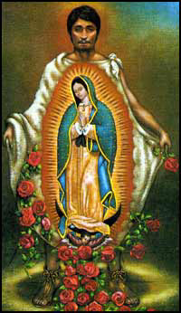
la fiesta de
La VIRGEN DE GUADALUPE

Todos están invitados a la celebración anual
de la Virgen de Guadalupe.

el jueves, 11 de diciembre
10:00pm ---------------------- La Procesión
11:00pm ---------------------- Los Matachines
Dos Temas
Las Mañanitas
12 medianoche -------------- La Misa
Después de Misa ------------ El Desayuno

el viernes, 12 de diciembre
5:00pm ---------------------- El Rosario
5:30pm ---------------------- La Aparición
La Cena
Después de Cena ----------- Matachines
Bailables

!!!Religious Education News!!!
1st-7th Grades, Wednesdays, 6:00-7:15 p.m.
8th-12th Grades,
Sundays,11:15 a.m. - 12:30 p.m.
Dates to Remember:
Dec 7 & 10: No RE classes Church Mission
Dec 21-Jan 4: Christmas Holiday, No R.E. Classes


DUNCAN COLLECTIONs FOR nov 29-30:

Duncan: $2,333.29
Weekly Electronic Donations: $1,225.00
Building: $50.00
Food Bank: $102.00
Ryan: $183.00
Thank you for your generosity!!!

Please remember your Parish in your will.
CHRISTMAS FLOWER DONATIONS
There are Envelopes in the pews for donations for our Christmas Flowers and Decorations.
Thank you for your generosity.

donaciones para flores de navidad
Hay Sobres en las bancas para donaciones para las Flores y Decoraciones de Navidad.
Gracias por su generosidad.

Saint Patrick Catholic Church
THIRD AND OHIO POST OFFICE BOX 151
Walters, Oklahoma 73572
**************************************
Collections:
Nov 30: Operating--$438.00/Building--$125.00

Please remember your Parish in your will.

