Our Lord Jesus Christ, King of the Universe
November 23, 2014

Mass Intentions / Peticiones de Misa

Sat | Nov 22 | 4:00p D | (+)John Park by  Parish Advent Mission:  "Christ is Born"  Presented by Fr. Joseph Arledge,  December 6-10, 2014  The Mission will end Wednesday,  December 10 at 7 p.m. with  Advent Penance Service.  Greg & Patty Winegardner
 |  | 6:00p R | For the Parishioners
Sun | Nov 23 | 8:00a M | (+)Ted Forsythe
 |  | 10:00a D | (+)Kathleen Capshaw  by Joe Murphey
 |  | 12:00p W | For the Parishioners
 |  | 2:00p D
Mon | Nov 24 | 12:10p D | Int of Mike & Chris McCoy  Second Annual Christmas Bazaar  December 5, 6 & 7, 2014 in Gillespie Hall  Friday, December 5, 4-8 p.m.  Saturday, December 6, 10 a.m.-7 p.m.  St. Nicholas Party for Children, 6-8 p.m.,  in R.E. Bldg  Sunday, December 7, 11 a.m. - 5 p.m.  Order Tamales by Carmen  at $25.00 per dozen.  Order and pay at the office  if you're interested!  Buy Raffle tickets now:  1. Beautiful Christmas centerpiece. Tickets are $1.00 each or six tickets for $5.00.  2. $500 Southwest Airlines Gift Card. Tickets are $5.00 each or five tickets for $20.00 or 5 tickets for $20.00!  Will be raffled off on Sunday, December 7 at Bazaar!  Proceeds will be distributed: 50% to the Building Fund, 25% to St. Vincent de Paul and 25% to our Food Bank. Everyone can contribute!  by Bill McCoy
Tues | Nov 25 | 12:10p D | NO MASS/OFFICE CLOSED
Wed | Nov 26 | 12:10p D | NO MASS/OFFICE CLOSED
Thur | Nov 27 | 12:10p D | NO MASS/OFFICE CLOSED
Fri | Nov 28 | 12:10p D | NO MASS/OFFICE CLOSED
Sat | Nov 29 | 4:00p D | (+)Andrew Rodiger
 |  | 6:00p D | (+)Buddy Gentry by His Sister  Theresa Blanchard
Sun | Nov 30 | 8:00a M | (+)Beverly Hoegger
 |  | 10:00a D | (+)Andrew Rodiger
 |  | 12:00p W
 |  | 2:00p D
Please notice: The office will be closed Tuesday, November 25-Friday, November 28 for the Thanksgiving Holiday. There will also be no daily Masses on Tuesday-Friday.

Christmas Mass Schedule
Wednesday, December 24
6 p.m. Duncan Children's Mass
6 p.m. Walters
Midnight Mass in Duncan
Thursday, December 25
9 a.m. Marlow
11 a.m. Duncan
11 a.m. Ryan

Baptismal Classes in English:
Sunday, December 14 after 8 a.m. Mass ,Immaculate Conception, Marlow presented by Deacon Jimmy Conway

Upcoming Events:

Mon., Dec 8: Immaculate Conception Feast Day Mass, 12:10 pm in Duncan and 7 p.m. in Marlow.
Sat-Wed, Dec 6-10: Parish Advent Mission
Wed, Dec 10: 7 p.m. Penance Advent Service
Wed., Dec 24: 6 p.m. Children's Mass

Altar Society No Bake, Bake Sale
Altar Society members voted to have a "No Bake, Bake Sale" so everyone could just make a donation instead of baking or buying. Therefore on the weekend of Nov 22-23 the Altar Society will be taking up collections. Thank you for your generosity.
You can have a Mass said for someone's intentions at their birthday, wedding, baptism, or in memory of your deceased loved ones. Contact he office for days and times that you wish to have the Mass celebrated. What a precious gift!

Abuse of Minors Pastoral Response Hotline 405-720-987 or DHS at 1-800-522-3511. Línea Telefónica Pastoral para Reportar Abuso de Menores 405-720-9878 o el Departamento de Servicios Humanos al 1-800-522-3511.

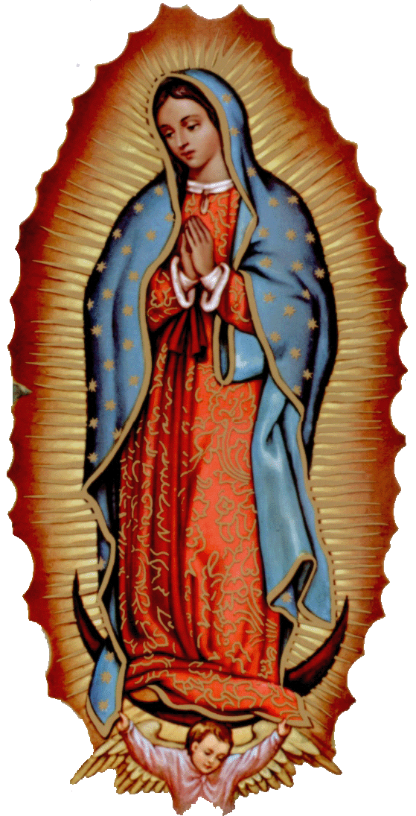
Church Donation Envelopes
Next year you will no longer receive donation envelopes in the mail. The entire year's envelopes will be available for you to pick up at the entrance of the Assumption Church or during the week in the Parish office. The envelopes should arrive shortly and we will let you know when you can pick them up!

Please Note: You can always donate via automatic withdrawal directly to our church's account. It is easy, simple and at the end of the fiscal year you will receive a tax letter acknowledging your donations. For more information stop by the office after each Mass.

Thank you for your support.
Our lady of Guadalupe celebration

Everyone is invited to the annual celebration
of the Virgin of Guadalupe.

Thursday, December 11
10:00pm ---------------------- Procession
11:00pm ---------------------- Matachines
(Traditional dancers)
Two Talks
Mañanitas
(Songs to Mary)
12 midnight ----------------- Mass
After Mass ------------------- Light Breakfast

Friday, December 12
4:30pm ------------------------ Rosary
5:00pm ------------------------ Apparition
6:00pm ------------------------ Mass
After Mass -------------------- Dinner
After Dinner ------------------ Matachines
Folkloric Dances



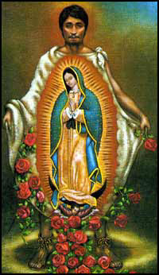
!!!Religious Education News!!!
1st-7th Grades, Wednesdays, 6:00-7:15 p.m.
8th-12th Grades, Sundays,11:15 a.m. - 12:30 p.m.
Dates to Remember:
Wed, Nov 26: Thanksgiving Break, No R.E. Class
Sun, Nov 30: Thanksgiving Break, No R.E. Class
Dec 21-Jan 4: Christmas Holiday, No R.E. Classes
la fiesta de
La VIRGEN DE GUADALUPE

Todos están invitados a la celebración anual
de la Virgen de Guadalupe.

el jueves, 11 de diciembre
10:00pm ---------------------- La Procesión
11:00pm ---------------------- Los Matachines
Dos Temas
Las Mañanitas
12 medianoche -------------- La Misa
Después de Misa ------------ El Desayuno

el viernes, 12 de diciembre
4:30pm ---------------------- El Rosario
5:00pm ---------------------- La Aparición
6:00pm ---------------------- La Misa
Después de Misa ----------- La Cena
Después de Cena ----------- Matachines
Bailables

DUNCAN COLLECTIONs FOR nov 15-16:
Duncan: $2,266.59
Weekly Electronic Donations: $1,225.00
Building: $25.00
Food Bank: $39.00
Ryan: $170.00
Thank you for your generosity!!!

Saint Patrick Catholic Church
THIRD AND OHIO POST OFFICE BOX 151
Walters, Oklahoma 73572
**************************************
Collections:
Nov 16: Operating--$987.15/Building--$125.00

CHRISTMAS FLOWER DONATIONS
There are Envelopes in the pews for donations for our Christmas Flowers and Decorations.
Thank you for your generosity.

donaciones para flores de navidad
Hay Sobres en las bancas para donaciones para las Flores y Decoraciones de Navidad.
Gracias por su generosidad.

Please remember your Parish in your will.

