Twenty-Ninth Sunday in Ordinary Time October 19, 2014

Mass Intentions / Peticiones de Misa

Sat | Oct 18 | 4:00p D | (+)Jo Ann McCoy by Bill McCoy  Second Annual Christmas Bazaar  December 5, 6 & 7, 2014 in R.E. Bldg.  Friday, December 5, 4-8 p.m.  Saturday, December 6, 10 a.m.-7 p.m.  St. Nicholas Party for Children, 6-8 p.m.,  in Gillespie Hall  Sunday, December 7, 11 a.m. - 5 p.m.  Order Tamales by Carmen  at $25.00 per dozen.  Order and pay at the office  if you're interested!  Buy Raffle tickets now:  1. Beautiful Christmas centerpiece. Tickets are $1.00 each or six tickets for $5.00.  2. $500 Southwest Airlines Gift Card. Tickets are $5.00 each or five tickets for $20.00 or 5 tickets for $20.00!  Will be raffled off on Sunday, December 7 at Bazaar!  Proceeds will be distributed: 50% to the Building Fund, 25% to St. Vincent de Paul and 25% to our Food Bank. Everyone can contribute!
 |  | 6:00p R | (+)Clarence L. Neal
Sun | Oct 19 | 8:00a M | (+)Alfred Pittman by KofC
 |  | 10:00a D | Good Health for Ross Power by Hal & Rosa Power
 |  | 12:00p W | For those affected by Breast Cancer
 |  | 2:00p D
Mon | Oct 20 | 12:10p D | (+)Clarence L. Neal
Tues | Oct 21 | 12:10p D | 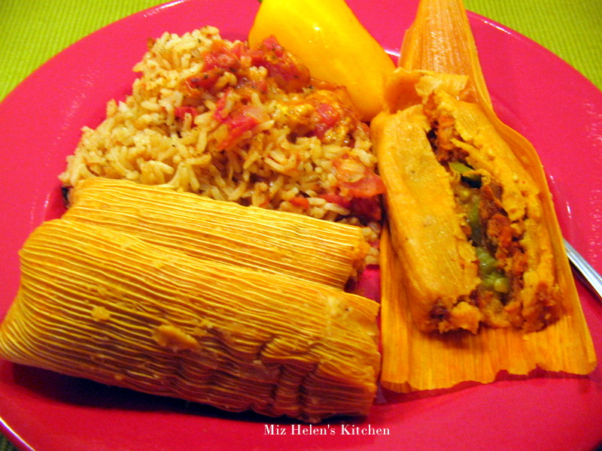(+)Clarence L. Neal
Wed | Oct 22 | 12:10p D | (+)Andrew Rodiger by  Ann & Troy Boice
Thur | Oct 23 | 12:10p D | (+)Andrew Rodiger by Roxanna, Greg and Maddison Lindesmith
Fri | Oct 24 | 12:10p D | (+)Clarence L. Neal
Sat | Oct 25 | 4:00p D | (+)Jo Ann McCoy  by Bill McCoy
 |  | 6:00p R
Sun | Oct26 | 8:00a M | (+)Alfred Pittman by KofC
 |  | 10:00a D | Mark Hebert God's Blessings on His Birthday by Ann Boice
 |  | 12:00p W
 |  | 2:00p D | Janet Snow for God's Blessings on Her Birthday by Ann Boice
Christmas Mass Schedule

Wednesday, December 24
6 p.m. Duncan Children's Mass
6 p.m. Walters
Midnight Mass in Duncan

Thursday, December 25
9 a.m. Marlow
11 a.m. Duncan
11 a.m. Ryan

Upcoming Events:

Sun., Oct 26: National Council of Catholic Women (NCCW) Sunday. Let's honor women in the church!
Mon-Fri,Oct 27-31: No Masses, Priests Retreat,
Dallas, TX
Sat., Nov 1: 12:10 p.m. All Saints Feast Day Mass
Sun, Nov 16: Children's Mass at 10 a.m.
Sun, Nov 23: Praise & Worship Mass at 6 p.m., Assumption
Mon., Dec 8: Immaculate Conception Feast Day Mass, 7 p.m. in Marlow, one Mass only

Collections in October:
Oct 18-19: Breast Cancer Foundation of America October is Breast Cancer Awareness Month. After Mass Altar Society Ladies will be dressed in pink to take your special donations!

Oct 25-26: Waters for Life, Builds water wells in a third world country

You can have a Mass said for someone's intentions at their birthday, wedding, baptism, or in memory of your deceased loved ones. Contact he office for days and times that you wish to have the Mass celebrated. What a precious gift!

Abuse of Minors Pastoral Response Hotline 405-720-987 or DHS at 1-800-522-3511. Línea Telefónica Pastoral para Reportar Abuso de Menores 405-720-9878 o el Departamento de Servicios Humanos al 1-800-522-3511.


!!!Religious Education News!!!
1st-7th Grades, Wednesdays
6:00-7:15 p.m.
8th-12th Grades, Sundays
11:15 a.m. - 12:30 p.m.
Dates to Remember:
Sun, Oct 19: Fall Break No R.E. Class
Sun, Oct 26: R. E. Class, Saint Fair
Wed, Nov 26: Thanksgiving Break, No R.E. Class
Sun, Nov 30: Thanksgiving Break, No R.E. Class
Dec 21-Jan 4: Christmas Holiday, No R.E. Classes

you'll be glad you did!
Rehearsals on Saturdays from 2:00-3:30 p.m. at Assumption of the Blessed Virgin Mary Church and Warm-ups on Sunday from 8:45-9:30 a.m.

Christmas Music Rehearsals:
Sunday, October 19: 11:05-12:15 a.m.

Anniversary Mass
Archbishop Coakley invites married couples who are celebrating milestone anniversaries (25, 40, 50+) in the calendar year 2014 to attend a special Anniversary Mass on Sunday, Nov. 16, at 3 p.m. at Our Lady of Perpetual Help Cathedral, 3214 North Lake Ave., (NW 32 & Western) Oklahoma City. A reception will follow. If you plan to attend, it is imperative that you contact the Office of Family Life at (405) 721-8944. The archbishop will be imparting his blessing, and the local Catholic community will rejoice in your example and commitment to the Sacrament of Marriage.

Misa Celebrando los Aniversarios 25, 40, 50+
El Arzobispo Pablo Coakley invita a las parejas casadas que estén celebrando su aniversario especial de (25, 40, 50+) el presente año 2014 para que asistan a una Misa Especial de Aniversario el domingo 16 de noviembre, 2014, iniciando a las 3 p.m. en la Catedral de Nuestra Señora del Perpetuo Socorro, 3214 North Lake Ave., (NW 32 y Western) en Oklahoma City. Después de la Misa habrá una recepción. Es muy importante que si usted desea asistir contacte a la Oficina de Vida Familiar al (405) 721-8944. El Arzobispo le dará su bendición y la comunidad local se alegrará en su ejemplo y compromiso al Sacramento de Matrimonio.

Baptismal Classes in English:
Sunday, October 26 and December 14
after 8 a.m. Mass
in Immaculate Conception, Marlow
presented by Deacon Jimmy Conway

Platicas del Sacramento de Bautizmo
en Español
Noviembre 8 Son a la 7 p.m. en La capilla.
Para mas informacioń
llame a la oficina
580-255-0590 ex 11,
o Carmen Garcia 580-255-6337 Gracias

Please remember your Parish in your will.
DUNCAN COLLECTIONs FOR oct 11-12:
Duncan: $2,166.37
Weekly Electronic Donations: $1,225.00
Building: Sanctuary Project: $75.00
Food Bank: $90.00
St Vincent de Paul: $10.00
World Mission Sunday: $20.00
Lady of Guadalupe Special Feast: $57.12
Scholarship: $3.00
Ryan: $214.00
Thank you for your generosity!!!

Saint Patrick Catholic Church
THIRD AND OHIO POST OFFICE BOX 151
Walters, Oklahoma 73572
**************************************
Collections:
Oct 12: Operating--$401.00/Building--$125.00

Encounter with God’s Call weekend
Come and See Weekend will be held Nov. 8-10 at Conception Seminary College. The weekend is a trip for young men who are juniors and seniors in high school and older who would like to visit a seminary. This is an excellent opportunity to meet seminarians who are discerning their call to the priesthood. This visit is sponsored by the Archdiocese of Oklahoma City Vocations Office and is free. Please contact your pastor or the Vocations Office at (405) 721-9351 or e-mail vocations@archokc.org. The deadline to register is Oct. 31.

