Twenty-Eighth Sunday in Ordinary Time October 12, 2014

Mass Intentions / Peticiones de Misa

Sat | Oct 11 | 4:00p D | Howard Doerr by  Second Annual Christmas Bazaar  December 5, 6 & 7, 2014 in R.E. Bldg.  Friday, December 5, 4-8 p.m.  Saturday, December 6, 10 a.m.-7 p.m.  St. Nicholas Party for Children, 6-8 p.m.,  in Gillespie Hall  Sunday, December 7, 11 a.m. - 5 p.m.  Order Tamales by Carmen  at $25.00 per dozen.  Order and pay at the office  if you're interested!  Buy Raffle tickets now:  1. Beautiful Christmas centerpiece. Tickets are $1.00 each or six tickets for $5.00.  2. $500 Southwest Airlines Gift Card. Tickets are $5.00 each or five tickets for $20.00.  Will be raffled off on Sunday, December 7 at Bazaar!  Proceeds will be distributed: 50% to the Building Fund, 25% to St. Vincent de Paul and 25% to our Food Bank. Everyone can contribute!  The Wolfgang-Deeg Family
 |  | 6:00p R | (+)George E. Coughlin
Sun | Oct 12 | 8:00a M | For the Parishioners
 |  | 10:00a D | (+)George E. Coughlin
 |  | 12:00p W | (+)Julia Ann Smith Sealy by Kathleen Flanagan
 |  | 2:00p D | (+)Clarence L. Neal
Mon | Oct 13 | 12:10p D | (+)Clarence L. Neal
Tues | Oct 14 | 12:10p D | 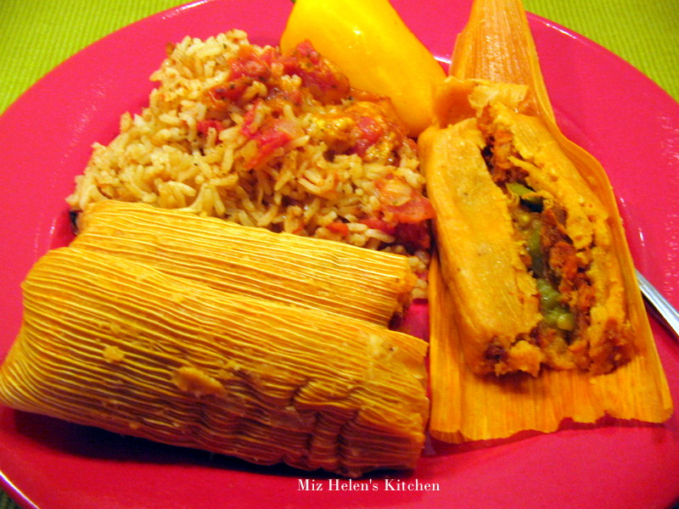(+)Don Trostle & Jake Seratte
Wed | Oct 15 | 12:10p D | (+)Clarence L. Neal
Thur | Oct 16 | 12:10p D | (+)Jose Vasquez by ESL Class
Fri | Oct 17 | 12:10p D | Int of Cecilia Dibbern for Health & Well Being
Sat | Oct 18 | 4:00p D | (+)Jo Ann McCoy  by Bill McCoy
 |  | 6:00p R | (+)Clarence L. Neal
Sun | Oct19 | 8:00a M | (+)Alfred Pittman by KofC
 |  | 10:00a D | Good Health for Ross Power by Hal & Rosa Power
 |  | 12:00p W | For those who are affected by Breast Cancer
 |  | 2:00p D | For the Parishioners

Baptismal Classes in English:
Sunday, October 26 and December 14
after 8 a.m. Mass
in Immaculate Conception, Marlow
presented by Deacon Jimmy Conway

Platicas del Sacramento de Bautizmo
en Español
Noviembre 8 Son a la 7 p.m. en La capilla.
Para mas informacioń
llame a la oficina
580-255-0590 ex 11,
o Carmen Garcia 580-255-6337 Gracias

Upcoming Events:

Sun., Oct 19: Children's Mass at 10 a.m.

Sun., Oct 26: National Council of Catholic Women (NCCW) Sunday. Let's honor women in the church!
Mon-Fri,Oct 27-31: No Masses, Priests Retreat,
Dallas, TX
Sat., Nov 1: 12:10 p.m. All Saints Feast Day Mass
Sun, Nov 16: Children's Mass at 10 a.m.
Sun, Nov 23: Praise & Worship Mass at 6 p.m., Assumption
Mon., Dec 8: Immaculate Conception Feast Day Mass, 7 p.m. in Marlow, one Mass only

Thank you to the pastor and parishioners of Assumption and Missions from the Monks of St. Gregory's Abbey and St. Gregory's University for allowing one of the Benedictine Monks to speak in your parish. Your generosity to the Catholic Scholarship Fund of $1,822.02 was received.
You can have a Mass said for someone's intentions at their birthday, wedding, baptism, or in memory of your deceased loved ones. Contact he office for days and times that you wish to have the Mass celebrated. What a precious gift!

Abuse of Minors Pastoral Response Hotline 405-720-987 or DHS at 1-800-522-3511. Línea Telefónica Pastoral para Reportar Abuso de Menores 405-720-9878 o el Departamento de Servicios Humanos al 1-800-522-3511.



you'll be glad you did!
Rehearsals on Saturdays from 2:00-3:30 p.m. at Assumption of the Blessed Virgin Mary Church and Warm-ups on Sunday from 8:45-9:30 a.m.

Christmas Music Rehearsals: Sunday, October 12: 11:05-12:15 a.m.

!!!Religious Education News!!!
1st-7th Grades, Wednesdays
6:00-7:15 p.m.
8th-12th Grades, Sundays
11:15 a.m. - 12:30 p.m.
Dates to Remember:

Wed, Oct 15: Fall Break No R.E. Class
Sun, Oct 19: Fall Break No R.E. Class
Sun, Oct 26: R. E. Class, Saint Fair
Wed, Nov 26: Thanksgiving Break, No R.E. Class
Sun, Nov 30: Thanksgiving Break, No R.E. Class
Dec 21-Jan 4: Christmas Holiday, No R.E. Classes

Women of Faith/Women of Action Conference
Saturday, October 18 at St. Eugene's Catholic Church, Oklahoma City

Mary, Woman of Grace
Registration at 8 a.m.
To register go online: okcaccw.com
Adults $40, Youth $25 and Religious no charge

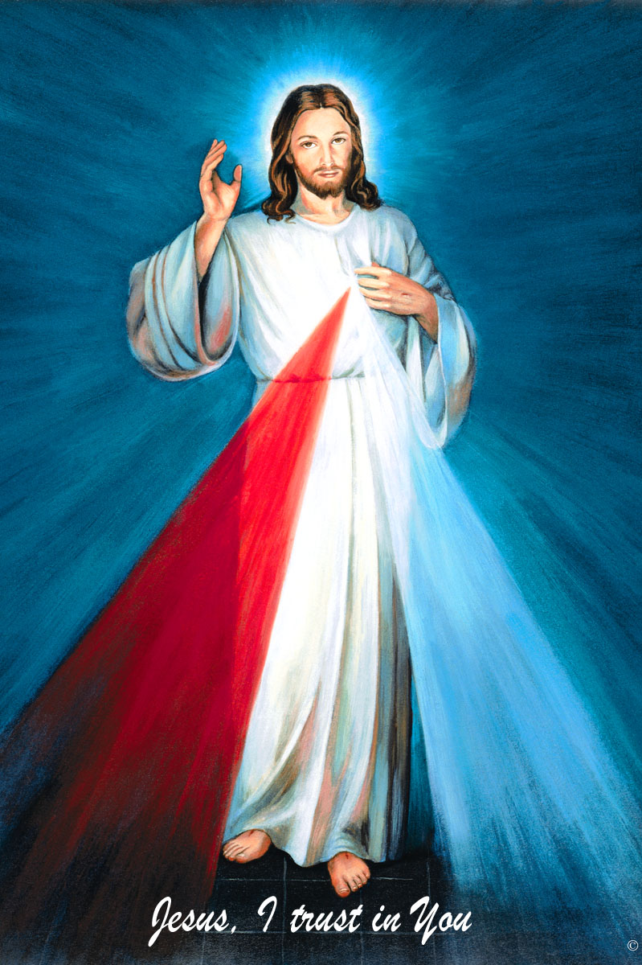
The Divine Mercy Chaplet
and Rosary are prayed
every day at 11:45 in our
Divine Mercy and
Blessed John Paul II
Chapel before our
12:10 Noon Mass.
Please come and spend time with Jesus!

Second Collections in October:

Oct 18-19: Breast Cancer Foundation of America October is Breast Cancer Awareness Month

Oct 25-26: Waters for Life, Builds water wells in a third world country
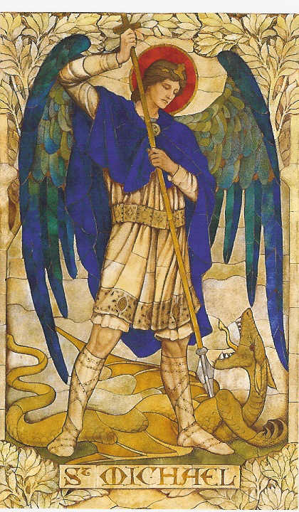
Please remember your Parish in your will.
Saint Patrick Catholic Church
THIRD AND OHIO POST OFFICE BOX 151
Walters, Oklahoma 73572
**************************************
Collections:
Oct 5: Operating--$420.00/Building--$941.00

DUNCAN COLLECTIONs FOR oct 4-5:
Duncan: $3,195.52
Weekly Electronic Donations: $1,225.00
Building: Sanctuary Project: $5,685.00
Ryan: $263.00
Food Bank: $105.00
St Vincent de Paul: $170.00
Thank you for your generosity!!!

Prayer to Saint Michael
the Archangel
St. Michael the Archangel, defend us in battle. Be our defense against the wickedness and snares of the Devil. May God rebuke him, we humbly pray, and do thou, O Prince of the heavenly hosts, by the power of God, thrust into hell Satan, and all the evil spirits, who prowl about the world seeking the ruin of souls. Amen
Please remember you can support
our Parish with electronic donations!
Sign up today!!!
In order for us to process your electronic donation, we will need from you: voided check and a signed authorization form. Please come to the office after one of our weekend Masses or during the week. For those of you that would like to increase your electronic donations please let us know.

