The Exaltation of the Holy Cross September 14, 2014

Upcoming Events:
Sun., Sep 21: Children's Mass at 10 a.m.
Sun., Oct 12, Celebration canceled see note below.
Sun., Oct 19: Children's Mass at 10 a.m.
Tues, Oct 21: Healing Mass at 7 p.m.
Sun., Oct 26: National Council of Catholic Women (NCCW) Sunday. Let's honor women in the church!
Sat., Nov 1: 12:10 p.m. All Saints Feast Day Mass
Sun, Nov 16: Children's Mass at 10 a.m.
Sun, Nov 23: Praise & Worship Mass at 6 p.m., Assumption
Mon., Dec 8: Immaculate Conception Feast Day Mass, 7 p.m. in Marlow, one Mass only

Mass Intentions / Peticiones de Misa

Sat | Sep 13 | 4:00p D | (+)George E. Coughlin
 |  | 6:00p R | For Parishioners
Sun | Sep 14 | 8:00a M | (+)Marvin Tucker by  Gail Boehm
 |  | 10:00a D | Birthday Blessings & Good Health for Ann Boice
 |  | 12:00p W | (+)Don Trostle and Jake Seratte
 |  | 2:00p D | (+)George E. Coughlin
Mon | Sep 15 | 12:10p D | (+)George E. Coughlin
Tues | Sep 16 | 12:10p D | (+)George E. Coughlin
Wed | Sep 17 | 12:10p D | (+)George E. Coughlin
Thur | Sep 18 | 12:10p D | (+)George E. Coughlin
Fri | Sep 19 | 12:10p D | (+)George E. Coughlin  Due to an unforeseen conflict in The Archbishop's schedule Most Reverend Paul Coakley will not be able to preside over our Sunday, October 12 Saint John Paul II Celebration Mass. Therefore our Celebration and Parish Appreciation Dinner will be postponed to a later date. All Masses will be as usual: 8 a.m. Marlow, 10 a.m. Duncan, 12 noon at Walters and Spanish Mass in Duncan at 2 p.m.
Sat | Sep 20 | 4:00p D | (+)Marvin Tucker by  Gail Boehm
 |  | 6:00p R | (+)George E. Coughlin
Sun | Sep 21 | 8:00a M | (+)Alfred Pittman by KofC
 |  | 10:00a D | (+)George E. Coughlin
 |  | 12:00p W | (+)Julia Ann Smith Sealy by Kathleen Flanagan
 |  | 2:00p D | (+)Justino Salazar
Second Annual Christmas Bazaar
December 5, 6 & 7, 2014 in R.E. Bldg.
Friday, December 5, 4-8 p.m.
Saturday, December 6, 10 a.m.-7 p.m.
St. Nicholas Party for Children, 6-8 p.m.,
in Gillespie Hall
Sunday, December 7, 11 a.m. - 5 p.m.

Work Meeting on Saturday, September 13 at
10 a.m. in the R.E. Building! Everyone invited!!!

Agnes' Eggrolls $25.00 per dozen. For sale now and preorder for Christmas. Call or come by the office if you're interested in ordering!

Buy Raffle tickets now:
1. Beautiful Christmas centerpiece. Tickets are $1.00 each or six tickets for $5.00.

2. $500 Southwest Airlines Gift Card. Tickets are $5.00 each.

Will be raffled off on Sunday, December 7 at Bazaar!

Proceeds will be distributed: 50% to the Building Fund, 25% to St. Vincent de Paul and 25% to our Food Bank. Everyone can contribute!

R.C.I.A. (Rite of Christian Initiation of Adults)
is a spiritual instructional and ritual process for adults. Those adults wishing to become members of the Catholic Church through the Sacraments of Baptism, Confirmation and the Eucharist are welcome and encouraged to inquire about the RCIA session starting soon. Please contact Mike Radtke (606-0283) for information on participating in this Rite.

ADORATION of
the Blessed Sacrament
Thursdays & Friday
September 11, 12 and
September 18
from 7:00-8:00 p.m., each evening

Altar Society News: We will collect dues of $10 this weekend! All ladies of the Parish are members of the Altar Society!
You can have a Mass said for someone's intentions at their birthday, wedding, baptism, or in memory of your deceased loved ones. Contact he office for days and times that you wish to have the Mass celebrated. What a precious gift!

Please notice: There will be a Parish Council meeting on Tuesday, September 16 at 7 p.m. The Finance Council will meet at 6 p.m.

Abuse of Minors Pastoral Response Hotline 405-720-987 or DHS at 1-800-522-3511. Línea Telefónica Pastoral para Reportar Abuso de Menores 405-720-9878 o el Departamento de Servicios Humanos al 1-800-522-3511.

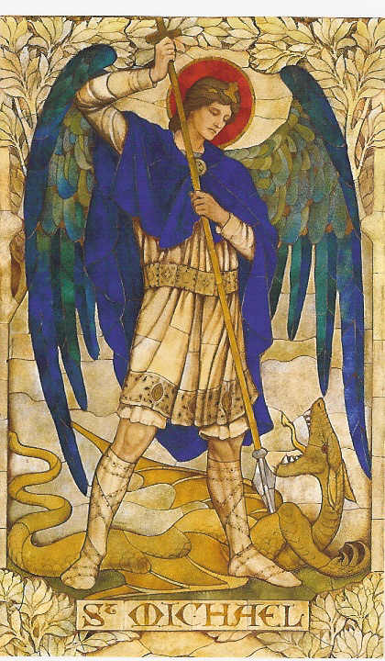
!!!Religious Education News!!!
1st-7th Grades, Wednesdays
6:00-7:15 p.m.
8th-12th Grades, Sundays
11:15 a.m. - 12:30 p.m.

Dates to Remember:
Wed, Sep 17: Mandatory Parents Meeting, 6:15 p.m., Assumption Church
Sun, Sep 21: Children's Mass at 10 a.m.
Sun, Oct 5: Teacher's Meeting, lunch provided
Prayer to Saint Michael
the Archangel
St. Michael the Archangel, defend us in battle. Be our defense against the wickedness and snares of the Devil. May God rebuke him, we humbly pray, and do thou, O Prince of the heavenly hosts, by the power of God, thrust into hell Satan, and all the evil spirits, who prowl about the world seeking the ruin of souls. Amen

Since the public Black Mass in Oklahoma City has not been canceled we're inviting you to join us for a prayerful act of reparation in the public square: Rosary Rally of Reparation of the Civic Center

When: Sunday, Sep 21 at 5:00-7:00 p.m.
Where: Civic Center, 201 N. Walker Ave, Oklahoma City, OK (Couch Drive & N Walker Avenue.
Your prayers will console Our Lord and the Blessed Mother. Bring your rosary. Bring your friends. Share this alert.

Women of Faith/Women of Action Conference
Saturday, October 18 at St. Eugene's Catholic Church, Oklahoma City
Mary, Woman of Grace
Registration at 8 a.m.
To register go online: okcaccw.com
Adults $40, Youth $25 and Religious no charge

2014 Annual Catholic Charities Appeal September20-21 Next Weekend
After all Masses
Second Collections in October:
Oct 18-19: Breast Cancer Foundation of America October is Breast Cancer Awareness Month

Oct 25-26: Waters of Life, Builds water wells in a third world country


DUNCAN COLLECTIONs FOR september 6-7:
Duncan: $3,495.00
Weekly Electronic Donations: $1,225.00
Catholic Food Bank: 120.00
St. Vincent de Paul: $430.00
Building: Sanctuary Project: $370.00
Altar Society Sanctuary Project: $1,000.00
Hispanic Guadalupe Burrito Sale
Sanctuary Project: $2,000.00
Ryan: $230.00
Thank you for your generosity!!!

you'll be glad you did!

Rehearsals on Saturdays from 2:00-3:30 p.m. at Assumption of the Blessed Virgin Mary Church and Warm-ups on Sunday from 8:45-9:30 a.m.

Note: Saturday, September 13 there is no choir practice only Sunday, September 14.

Saint Patrick Catholic Church
THIRD AND OHIO POST OFFICE BOX 151
Walters, Oklahoma 73572
**************************************
Collections:
September 7:
Operating--$517.10
Building--$2,382.00

Please remember you can support
our Parish with electronic donations!
Sign up today!!!
In order for us to process your electronic donation, we will need from you: voided check and a signed authorization form. Please come to the office after one of our weekend Masses or during the week. For those of you that would like to increase your electronic donations please let us know.

Please remember your Parish in your will.

