Sunday of Divine Mercy
April 27, 2014

Mass Intentions / Peticiones de Misa MisaMisa

Sat | Apr 26 | 4:00p D | Int of the Wongpradit Family  !!!Religious Education News!!!  Dates to Remember:  Last Classes: Sun, May 4/Wed, May 7  First Communion Rehearsal: Sat, May 3  First Communion: Sunday, May 4 at 10 a.m.  Children's Mass: Sunday, May 11 at 10 a.m.  Confirmation Rehearsal: Wed, May 14 at 6 p.m.  Confirmation: Friday, May 16 at 5 p.m.
 |  | 6:00p R | Int of Juan Mendoze & Juan Mendosa Ocha
Sun | Apr 27 | 8:00a M | (+)Ted Forsythe by  AC & Brett Gray
 |  | 10:00a D | (+)Joseph Pham Pham
 |  | 12:00p W | Int of the Church Family
 |  | 6:00p D | HEALING MASS
Mon | Apr 28 | 12:10p D | (+)Beverlie Lowe by  The Pittman Family
Tues | Apr 29 | 12:10p D | Int of Michael, Jason, & Winifred Gossman  NEWS on Catholic Radio KKNG 97.3
Wed | Apr 30 | 12:10p D | Int of Richard
Thur | May 1 | 12:10p D | For the Living & Deceased Members of the Altar Society  Children's Choir Practice Thursdays at 6 p.m.! Reunión del Coro de los niños, Jueves a las 6p.m.
Fri | May 2 | 12:10p D | (+)George E. Coughlin
Sat | May 3 | 4:00p D | (+)George E. Coughlin
 |  | 6:00p R | For the Living & Deceased Members of the Knights of Columbus | Platicas del Sacramento de Bautizmo  en Español  del año 2014 Serań en:  Junio 14, Septiembre 6, Noviembre 8  Son a la 7 p.m. en La capilla.  Para mas informacioń  llame a la oficina  580-255-0590 ex 11,  o Carmen Garcia 580-255-6337 Gracias
Sun | May 4 | 8:00a M | (+)Ted Forsythe | In memory of your deceased loved ones please have a  Mass offered for them.  Contact the office for days and times that you wish to have the  Mass celebrated.  What a precious gift!
 |  | 10:00a D | (+)George E. Coughlin
 |  | 12:00p W | (+)Ray & Shirley Cielenski
 |  | 2:00p D | (+)Rodolfo Barrientos, Jr.,  by The Family | FIRST FRIDAY ADORATION  ADORACIÓN _{DEL} 1er VIERNES  August 2  from 12:30 pm (after mass) - 9 pm  Benediction will be from 8:45 - 9 pm  de 12:30 pm (después de misa) - 9 pm  La Bendición será de 8:45 - 9 pm  FIRST FRIDAY ADORATION  April 5  from 12:30 pm (after mass) - 9 pm  Benediction will be from 8:45 - 9 pm  FIRST FRIDAY ADORATION  April 5  from 12:30 pm (after mass) - 9 pm  Benediction will be from 8:45 - 9 pm

FIRST FRIDAY ADORATION
ADORACIÓN _{DEL} 1er VIERNES
may 1
from 12:30 pm (after mass) - 9 pm
Benediction will be from 8:45 - 9 pm
de 12:30 pm (después de misa) - 9 pm
La Bendición será de 8:45 - 9 pm

Duncan Altar Society News:
The Altar Society Gift Shop
has many new items!

There is an Altar Society Meeting
Thursday, May 1
after the 12:10 pm Mass.
Bring a dish to share and a friend!

Please remember you can support
your Church with automatic donations!
Sign up today to automatically donate
your Sunday offering especially
during vacation times!
In order for us to process your automatic donation, we will need from you: voided check and a signed authorization form. Please come to the office after one of our weekend Masses or during the week. For those of you that would like to increase your automatic donations please let us know. We encourage you to sign up for automatic donations if you haven't already!

Attention
Choir Practice Schedule
Thursdays 7:00 - 8:15 p.m.
We invite those interested in singing in the Choir to join us for practice
in the Choir Loft!
Choir Review will be:
3:00-3:30 p.m. Saturdays
9:00-9:30 a.m. Sundays

Abuse of Minors Pastoral Response Hotline 405-720-9878 You may also contact Oklahoma Department of Human Services at 1-800-522-3511.
Línea Telefónica Pastoral para Reportar Abuso de Menores 405-720-9878 También puede comunicarse con el Departamento de Servicios Humanos al 1-800-522-3511.

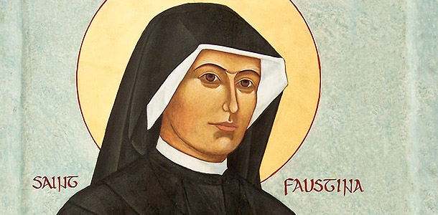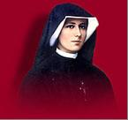

If you can't go to Rome, Italy come to
Duncan, Oklahoma to celebrate
Canonization of
St. John Paul II !!!

Divine Mercy Sunday, April 27
Celebrate St. John Paul II and
Divine Mercy Chapel

Come Pray the
Novena, Chaplet & Rosary on:

Good Friday at 6 p.m.

Holy Saturday at 7 p.m.
Easter Sunday at 9 a.m.

Monday - Friday, April 21-25
at 11:30 a.m. before daily Mass

Saturday, April 26 @ 3:30 p.m.

Divine Mercy Sunday, April 27
We will sing the Chaplet
starting at 5 p.m.

Healing Mass and the blessing with the Relic of blood of
Saint John Paul II
at 6 p.m.

Reception follows Mass

Si no puedes ir a Roma Italia
ven a Duncan a celebrar la Canonización de Santo Juan Pablo II

Divina Misericordia Domingo,
27 de abril

Oremos juntos la novena en la capilla

Viernes Santo a las 6 pm
Sábado Santo a las 7 pm
Domingo de resurrección a las 9 am
Lunes a viernes, abril 21-25 a las 11:30 am
antes de la misa diaria

Sábado, 6 de abril a las 3:30 pm

No hay misa el domingo de pascua,
20 de abril a las 2 pm. Todos son invitados para la misa bilingüe a las
10 am.

No hay misa el domingo 27 de abril a las 2 pm. Todos son invitados para la misa de las 6 pm.

Misa de Sanación a las 6 pm con la bendición con la reliquia de sangre del Santo Juan Pablo II
Comenzamos a las 5 pm con novena de divina misericordia

Habrá recepción después de la misa

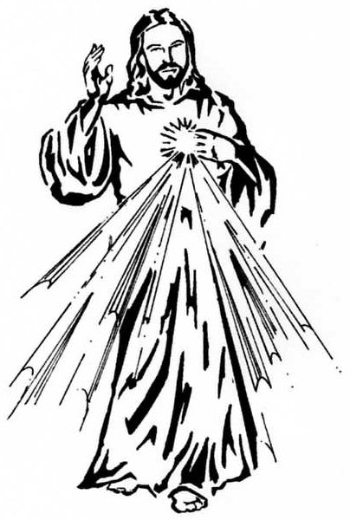

DUNCAN COLLECTIONs FOR
april 19-20:
Duncan: $
Weekly Direct Deposit Donations: $1,100.00
Building: $
Food Bank: $ St. Vincent de Paul: $

Saint Patrick Catholic Church
THIRD AND OHIO POST OFFICE BOX 151
Walters, Oklahoma 73572
**************************************
Collections:
April 19-20:
Operating-$
Building-$

Please remember your Parish in your will.

