Easter Sunday of the Resurrection of the Lord April 20, 2014

Mass Intentions / Peticiones de Misa MisaMisa

Sat | Apr 19 | 4:00p D | HOLY SATURDAY  May the Lord enlighten your days with the blessing of His resurrection. Happy Easter Fr. Peter and Fr. Bala Raju
Sun | Apr 20 | 8:00a M | (+)Ted Forsythe by  AC & Brett Gray
 |  | 10:00a D | Int of Cindy, Chloe & Erik
 |  | 12:00p W | (+)Frank & Majorie  The Well Outreach Program,  Meeting Tuesday, April 22 at  913 W. Main Street  (old JC Penney Building) at 7 p.m.  If you would like to  help our children please come.  Volunteers needed!
Mon | Apr 21 | 12:10p D | (+)Jo Ann McCoy by Bill McCoy
Tues | Apr 22 | 12:10p D | For the Living & Deceased Members of the Altar Society
Wed | Apr 23 | 12:10p D | (+)Don Trostle and Jake Seratte
Thur | Apr 24 | 12:10p D | Birthday Blessings and Good Health for Pat Neal by Ann Boice
Fri | Apr 25 | 12:10p D | Int of the Linnebour Family
Sat | Apr 26 | 4:00p D | Int of the Wongpradit Family
 |  | 6:00p R | Int of Juan Mendoze & Juan Mendosa | SCHOLARSHIPS - REMINDER-REMINDER  Assumption Catholic Church and the Knights of Columbus Council 5168 are again accepting applications for the Jesse Wayne Moore Scholarships. The graduating seniors wishing to apply for this scholarship may submit the application and necessary documents ON OR BEFORE MONDAY APRIL 21 to the church office or Jim Surjaatmadja. All applications will be judged on parish and community activities and scholarship achievements.  A note to all Parish Members: On behalf of the Knights and the graduating Seniors we would like to thank everyone for the generous contributions that help make this Scholarship Program continue throughout the years to come. But, we will need your support again. For this we ask for your continued monthly contributions. Please write your checks payable to Assumption Church Scholarship Fund. Thank you again for your continued support!!! Jim Surjaatmadja, Scholarship Chairman, Knights of Columbus 5168.
Sun | Apr 27 | 8:00a M | (+)Ted Forsythe | In memory of your deceased loved ones please have a  Mass offered for them.  Contact the office for days and times that you wish to have the  Mass celebrated.  What a precious gift!
 |  | 10:00a D | (+)Joseph Pham Pham
 |  | 12:00p W | Int of the Church Family
 |  | 2:00p D | NO MASS | FIRST FRIDAY ADORATION  ADORACIÓN _{DEL} 1er VIERNES  August 2  from 12:30 pm (after mass) - 9 pm  Benediction will be from 8:45 - 9 pm  de 12:30 pm (después de misa) - 9 pm  La Bendición será de 8:45 - 9 pm  FIRST FRIDAY ADORATION  April 5  from 12:30 pm (after mass) - 9 pm  Benediction will be from 8:45 - 9 pm  FIRST FRIDAY ADORATION  April 5  from 12:30 pm (after mass) - 9 pm  Benediction will be from 8:45 - 9 pm
Please Note: The office will be CLOSED April 21, Easter Monday.

!!!Religious Education News!!!
Dates to Remember:
Last Classes: Sun, May 4/Wed, May 7
First Communion Rehearsal: Sat, May 3
First Communion: Sunday, May 4 at 10 a.m.
Children's Mass: Sunday, May 11 at 10 a.m.
Confirmation Rehearsal: Wed, May 14 at 6 p.m.
Confirmation: Friday, May 16 at 5 p.m.

Please remember you can support
your Church with automatic donations!
Sign up today to automatically donate
your Sunday offering especially
during vacation times!
In order for us to process your automatic donation, we will need from you: voided check and a signed authorization form. Please come to the office after one of our weekend Masses or during the week. For those of you that would like to increase your automatic donations please let us know. We encourage you to sign up for automatic donations if you haven't already!

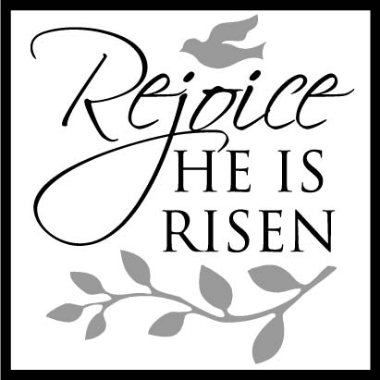

Attention Kids: Easter Egg Hunt
The Knights of Columbus will sponsor
an Easter Egg Hunt after
all Easter Sunday Masses in
Marlow, Walters and Duncan.
All children are invited to participate.

Duncan Altar Society News:
The Altar Society Gift Shop
has many new items!

Abuse of Minors Pastoral Response Hotline 405-720-9878 You may also contact Oklahoma Department of Human Services at 1-800-522-3511.
Línea Telefónica Pastoral para Reportar Abuso de Menores 405-720-9878 También puede comunicarse con el Departamento de Servicios Humanos al 1-800-522-3511.

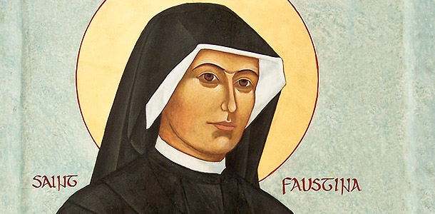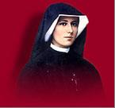

Si no puedes ir a Roma Italia
ven a Duncan a celebrar la Canonización de Santo Juan Pablo II

Divina Misericordia Domingo,
27 de abril

Oremos juntos la novena en la capilla

Viernes Santo a las 6 pm
Sábado Santo a las 7 pm
Domingo de resurrección a las 9 am
Lunes a viernes, abril 21-25 a las 11:30 am
antes de la misa diaria

Sábado, 6 de abril a las 3:30 pm

No hay misa el domingo de pascua,
20 de abril a las 2 pm. Todos son invitados para la misa bilingüe a las
10 am.

No hay misa el domingo 27 de abril a las 2 pm. Todos son invitados para la misa de las 6 pm.

Misa de Sanación a las 6 pm con la bendición con la reliquia de sangre del Santo Juan Pablo II
Comenzamos a las 5 pm con novena de divina misericordia

Habrá recepción después de la misa

If you can't go to Rome, Italy come to
Duncan, Oklahoma to celebrate
Canonization of
St. John Paul II !!!

Divine Mercy Sunday, April 27
Celebrate St. John Paul II and
Divine Mercy Chapel

Come Pray the
Novena, Chaplet & Rosary on:

Good Friday at 6 p.m.

Holy Saturday at 7 p.m.
Easter Sunday at 9 a.m.

Monday - Friday, April 21-25
at 11:30 a.m. before daily Mass

Saturday, April 26 @ 3:30 p.m.

Divine Mercy Sunday, April 27
We will sing the Chaplet
starting at 5 p.m.

Healing Mass and the blessing with the Relic of blood of
Saint John Paul II
at 6 p.m.

Reception follows Mass



Please remember your Parish in your will.
Saint Patrick Catholic Church
THIRD AND OHIO POST OFFICE BOX 151
Walters, Oklahoma 73572
**************************************
Collections:
April 13:
Operating-$
Building-$

DUNCAN COLLECTIONs FOR
april 12-13:
Duncan: $2,331.89
Weekly Direct Deposit Donations: $1,100.00
Building: $220.00
Food Bank: $110.00 St. Vincent de Paul: $233.00
Easter Flowers $443.81
Scholarship Fund: $15.00
Ryan $250.00

