Palm Sunday of the Passion of the Lord April 13, 2014

Mass Intentions / Peticiones de Misa MisaMisa

Holy Week and Easter Mass/Service Schedule

Holy Thursday, April 17 at 7 p.m.
Good Friday, April 18 at 7 p.m.
Holy Saturday, April 19 at 8 p.m.

Easter Sunday, april20:

Marlow at 8 a.m.
Duncan at 10 a.m.
Walters at 12 Noon

Please note that Holy Thursday, Good Friday and Holy Saturday will only be
celebrated in Duncan.

Sat | Apr 12 | 4:00p D | Int of Sharon, Katie, Pat R. Turley
 |  | 6:00p R | Int of Daniel, Francisa & Rogelio
Sun | Apr 13 | 8:00a M | (+)Ted Forsythe by  AC & Brett Gray
 |  | 10:00a D | (+)Ruth Kern by Kevin Moore
 |  | 12:00p W | For the Parishioners
 |  | 2:00p D | Int of Tony, Stella, William and Sophia | We would like to invite everyone to attend a Good-bye Party for Fr. Joseph on Sunday, June 30 at 5 p.m. in Gillespie Hall. The Knights of Columbus are providing hamburgers and hot dogs. We will have a money tree for Fr. Joseph.  We would like to invite everyone to attend a Good-bye Party for Fr. Joseph on Sunday, June 30 at 5 p.m. in Gillespie Hall. The Knights of Columbus are providing hamburgers and hot dogs. We will have a money tree for Fr. Joseph.
Mon | Apr 14 | 12:10p D | NO MASS
Tues | Apr 15 | 12:10p D | NO MASS
Wed | Apr 16 | 12:10p D | NO MASS
Thur | Apr 17 | 7:00p D | HOLY THURSDAY
Fri | Apr 18 | 7:00p D | GOOD FRIDAY  If you can't go to Rome, Italy come to  Duncan, Oklahoma to celebrate  Canonization of St. John Paul II !!!  Divine Mercy Sunday, April 27  Celebrate St. John Paul II and  Divine Mercy Chapel  Come Pray the  Novena, Chaplet & Rosary on:  Good Friday at 6 p.m.  Holy Saturday at 7 p.m.  Easter Sunday at 9 a.m.  Monday - Friday, April 21-25  at 11:30 a.m. before daily Mass  Saturday, April 26 @ 3:30 p.m.  Divine Mercy Sunday, April 27  We will sing the Chaplet  starting at 5 p.m.  Healing Mass and the blessing with the Relic of blood of  Saint John Paul II  at 6 p.m.  Reception follows Mass
Sat | Apr 19 | 8:00p D | HOLY SATURDAY
Sun | Apr 20 | 8:00a M | (+)Ted Forsythe | In memory of your deceased loved ones please have a  Mass offered for them.  Contact the office for days and times that you wish to have the  Mass celebrated.  What a precious gift!
 |  | 10:00a D | Int of Cindy, Chloe & Erik
 |  | 12:00p W | (+)Frank & Marjorie | FIRST FRIDAY ADORATION  ADORACIÓN _{DEL} 1er VIERNES  August 2  from 12:30 pm (after mass) - 9 pm  Benediction will be from 8:45 - 9 pm  de 12:30 pm (después de misa) - 9 pm  La Bendición será de 8:45 - 9 pm  FIRST FRIDAY ADORATION  April 5  from 12:30 pm (after mass) - 9 pm  Benediction will be from 8:45 - 9 pm  FIRST FRIDAY ADORATION  April 5  from 12:30 pm (after mass) - 9 pm  Benediction will be from 8:45 - 9 pm
Si no puedes ir a Roma Italia
ven a Duncan a celebrar la Canonización de Santo Juan Pablo II

Divina Misericordia Domingo,
27 de abril

Oremos juntos la novena en la capilla

Viernes Santo a las 6 pm
Sábado Santo a las 7 pm
Domingo de resurrección a las 9 am
Lunes a viernes, abril 21-25 a las 11:30 am
antes de la misa diaria

Sábado, 6 de abril a las 3:30 pm

No hay misa el domingo de pascua,
20 de abril a las 2 pm. Todos son invitados para la misa bilingüe a las 10 am.

No hay misa el domingo 27 de abril a las 2 pm. Todos son invitados para la misa de las 6 pm.

Misa de Sanación a las 6 pm con la bendición con la reliquia de sangre del Santo Juan Pablo II
Comenzamos a las 5 pm con novena de divina misericordia
Habrá recepción después de la misa
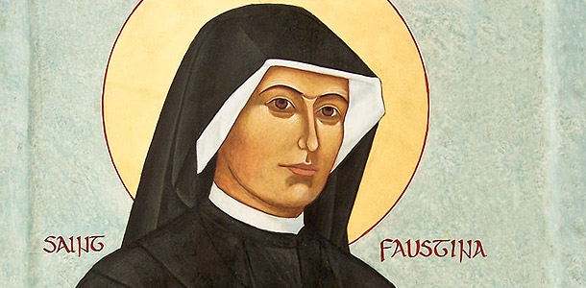

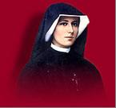
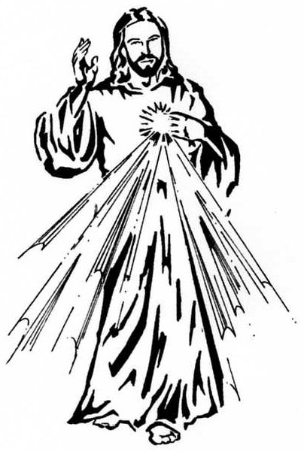

Second Collection this Weekend!
Collection for Easter flowers.
Thank you for your generosity!

Abuse of Minors Pastoral Response Hotline 405-720-9878 You may also contact Oklahoma Department of Human Services at 1-800-522-3511.
Línea Telefónica Pastoral para Reportar Abuso de Menores 405-720-9878 También puede comunicarse con el Departamento de Servicios Humanos al 1-800-522-3511.

!!!Religious Education News!!!
Dates to Remember:
No Classes: Wed, April 16/Sun, Apr 20
Last Classes: Sun, May 4/Wed, May 7
First Communion Rehearsal: Sat, May 3
First Communion: Sunday, May 4 at 10 a.m.
Children's Mass: Sunday, May 11 at 10 a.m.
Confirmation Rehearsal: Wed, May 14 at 6 p.m.
Confirmation: Friday, May 16 at 5 p.m.

Duncan Altar Society News:
The Altar Society Gift Shop
has many new items!

Remember the
Easter Bake Sale
This Weekend!
Get your Easter dessert TODAY!


"Rome Sweet Home" by Scott & Kimberly Hahn
Receive your free copy of this inspirational book on Palm Sunday after all weekend Masses! This is being provided courtesy of the R.C.I.A. Group and The Knights of Columbus.
Attention Kids: Easter Egg Hunt
The Knights of Columbus will sponsor
an Easter Egg Hunt after
all Easter Sunday Masses in
Marlow, Walters and Duncan.
All children are invited to participate.

Immaculate Conception
Seder Meal in Marlow
Wednesday, April 16 at 5:30 p.m.
Sign up by Monday, April 14
Call Fran at 580-658-7007



ATTENTION:
There will be NO DAILY MASS
Monday, Tuesday and Wednesday
April 14, 15 & 16!
Thank you to Ramon Gutierrez and his crew for donating their time and talent installing the cement pad for the storage building behind our Food Bank. --Fr. Peter

Please Note: The office will be CLOSED April 14-18, Monday-Friday of the Holy Week and April 21, Easter Monday.

SCHOLARSHIPS - REMINDER-REMINDER
Assumption Catholic Church and the Knights of Columbus Council 5168 are again accepting applications for the Jesse Wayne Moore Scholarships. The graduating seniors wishing to apply for this scholarship may submit the application and necessary documents ON OR BEFORE MONDAY APRIL 21 to the church office or Jim Surjaatmadja. All applications will be judged on parish and community activities and scholarship achievements.

A note to all Parish Members: On behalf of the Knights and the graduating Seniors we would like to thank everyone for the generous contributions that help make this Scholarship Program continue throughout the years to come. But, we will need your support again. For this we ask for your continued monthly contributions. Please write your checks payable to Assumption Church Scholarship Fund. Thank you again for your continued support!!! Jim Surjaatmadja, Scholarship Chairman, Knights of Columbus 5168.

Saint Patrick Catholic Church
THIRD AND OHIO POST OFFICE BOX 151
Walters, Oklahoma 73572
**************************************
Collections:
April 6:
Operating-$558.23
Building-$577.00

Please remember you can support
your Church with automatic donations!
Sign up today to automatically donate
your Sunday offering especially
during vacation times!
In order for us to process your automatic donation, we will need from you: voided check and a signed authorization form. Please come to the office after one of our weekend Masses or during the week. For those of you that would like to increase your automatic donations please let us know. We encourage you to sign up for automatic donations if you haven't already!

DUNCAN COLLECTIONs FOR
april 5-6:
Duncan: $3,051.03
Weekly Direct Deposit Donations: $1,100.00
Building: $45.00
Food Bank: $189.50 St. Vincent de Paul: $220.00
Easter Flowers $279.03
Ryan $199.00

Please remember your Parish in your will.

