Seventh Sunday in Ordinary Time
February 23, 2014

ATTENTION: No Daily Mass on Tuesday, February 25. Clergy Days in Oklahoma City!
Mass Intentions / Peticiones de Misa MisaMisa

Sat | Feb 22 | 4:00p D | (+)Kathleen Capshaw
 |  | 6:00p R | (+)Josephine and Ludvica | Adult Study with Fr. Peter,  "Introduction to the  Old and New Testament."  Come Learn How the Bible Came to Be!  Mondays , March 3, 10, 17 & 24  at 6:30 p.m. in Gillespie Hall.  Please bring your Bibles and a friend!
Sun | Feb 23 | 8:00a M | (+)Joseph Lockovich by  The Pittman Family
 |  | 10:00a D | (+)Jo Ann McCoy by Bill McCoy
 |  | 12:00p W | For the Parishioners
 |  | 2:00p D | For God's Blessings for  Paul & Kolleen | We would like to invite everyone to attend a Good-bye Party for Fr. Joseph on Sunday, June 30 at 5 p.m. in Gillespie Hall. The Knights of Columbus are providing hamburgers and hot dogs. We will have a money tree for Fr. Joseph.  We would like to invite everyone to attend a Good-bye Party for Fr. Joseph on Sunday, June 30 at 5 p.m. in Gillespie Hall. The Knights of Columbus are providing hamburgers and hot dogs. We will have a money tree for Fr. Joseph.
Mon | Feb 24 | 12:10p D | (+)Kathleen Capshaw
Tues | Feb 25 | 12:10p D | 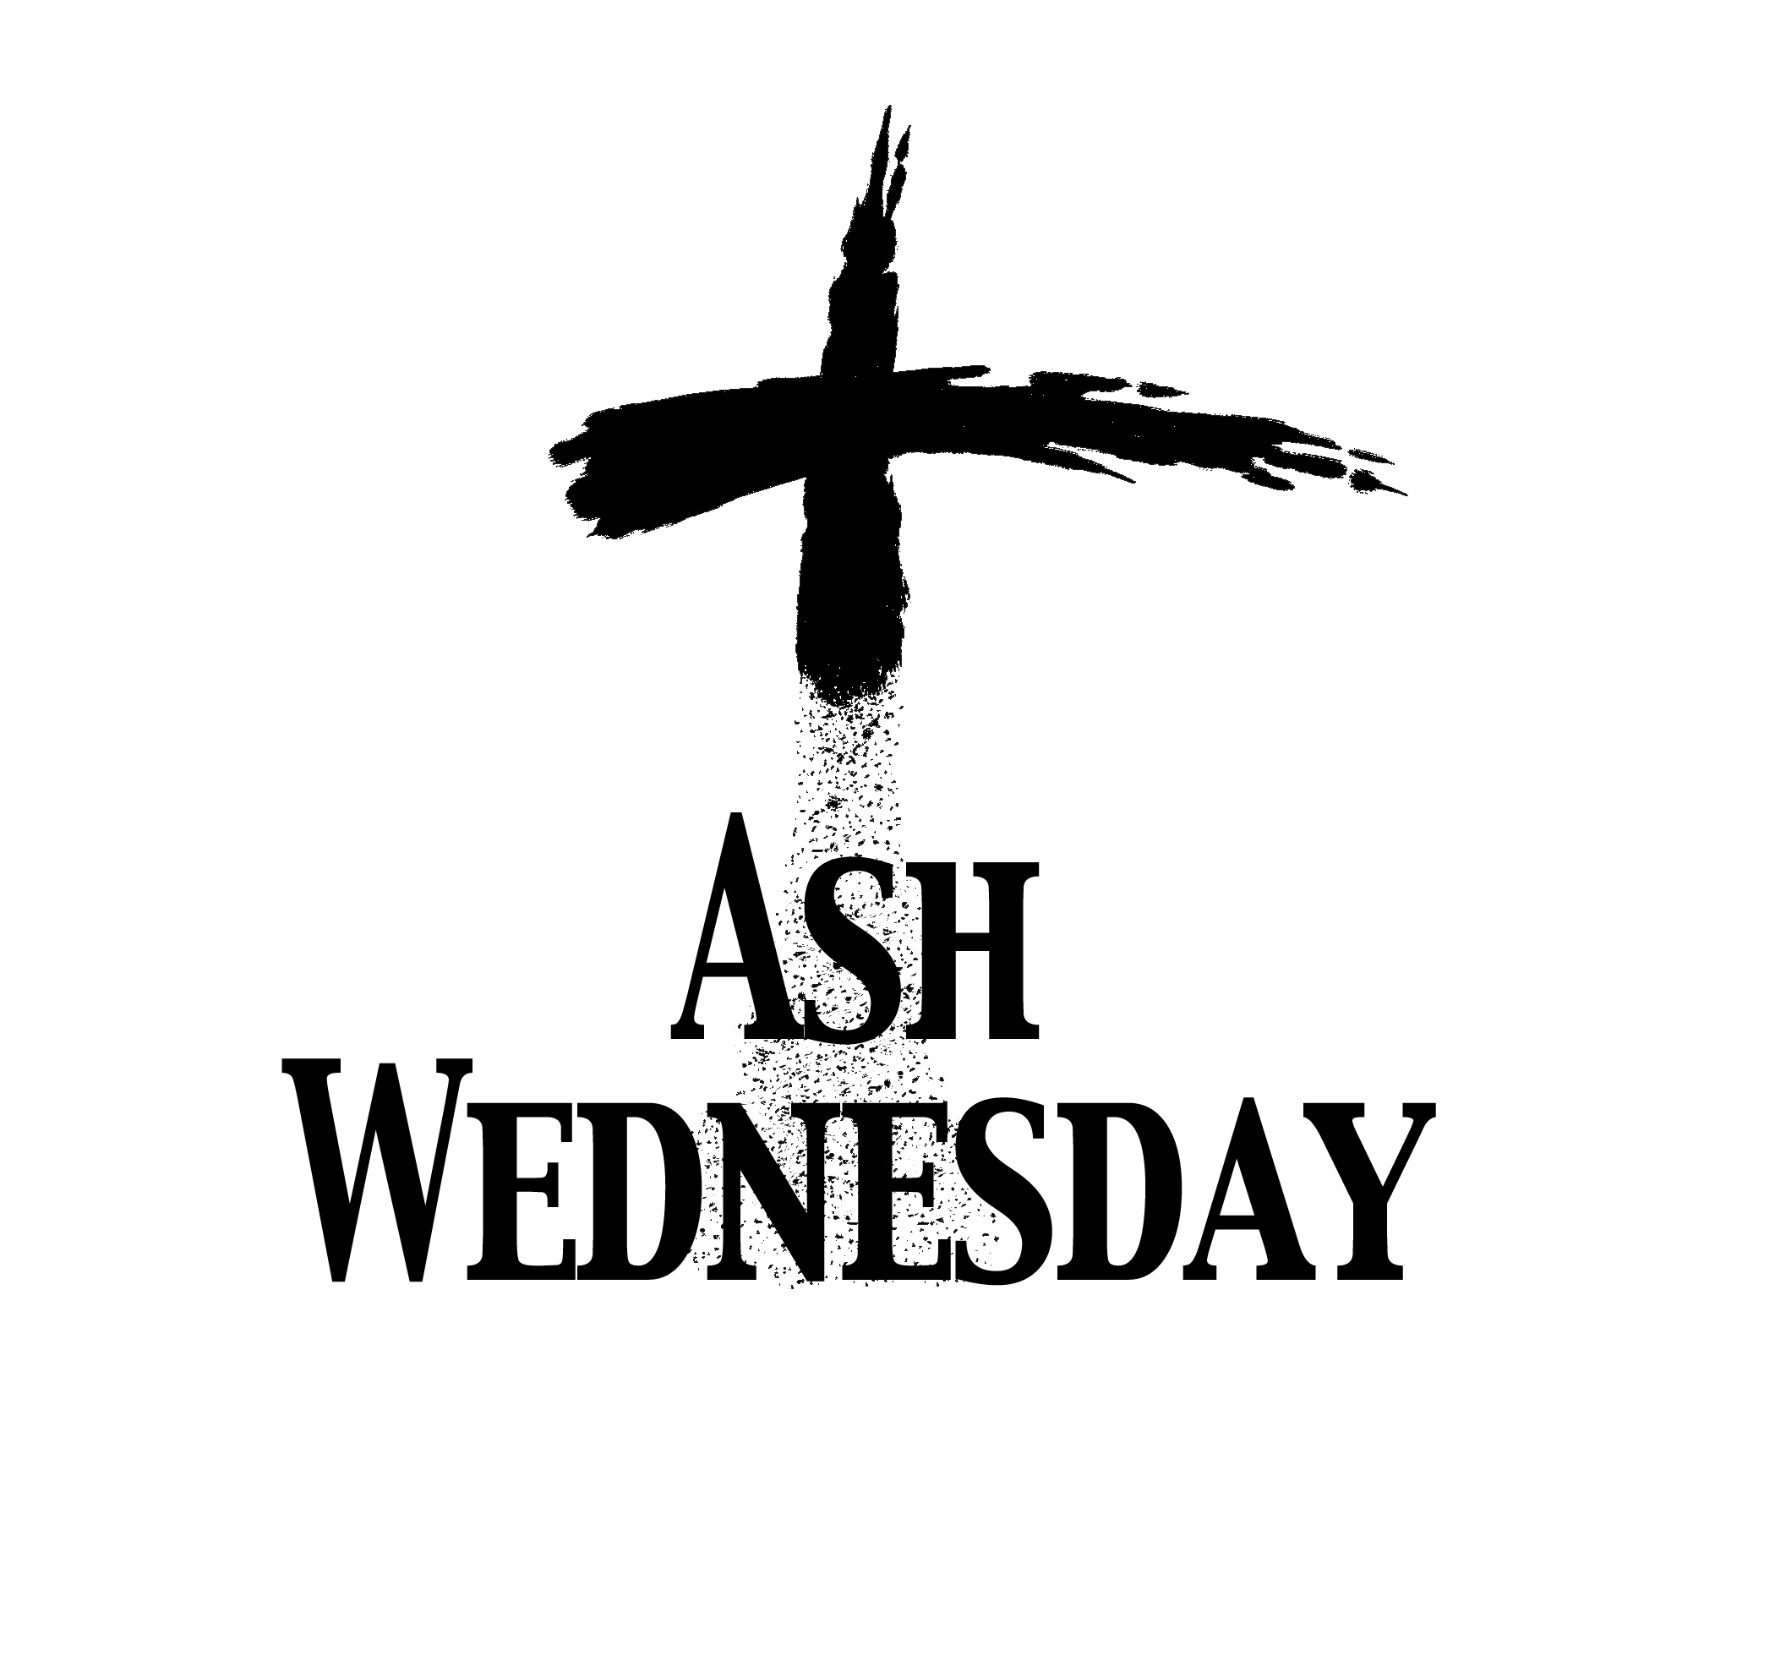NO MASS - CLERGY DAYS IN OKC  Ash Wednesday Service  Assumption Church, Duncan  Wednesday, March 5  7 a.m.  12:10 p.m.  7 p.m.
Wed | Feb 26 | 12:10p D | (+)Joseph Pham Van Pham
Thur | Feb 27 | 12:10p D | (+)Kathleen Capshaw
Fri | Feb 28 | 12:10p D | (+)Maurice & Bernadette Murphey | In memory of your deceased loved ones please have a  Mass offered for them.  Contact the office for days and times that you wish to have the  Mass celebrated.  What a precious gift!
Sat | Mar 1 | 4:00p D | (+)Maurice & Bernadette Murphey
 |  | 6:00p R | For the Parishioners | Second Collection this Weekend!  Continuing this weekend until the Holy Week  we will be taking a Second Collection for Easter flowers, decorations and children's Easter Egg Hunt. Thank you for your generosity.
Sun | Mar 2 | 8:00a M
 |  | 10:00a D | (+)Jo Ann McCoy by Bill McCoy | FIRST FRIDAY ADORATION  ADORACIÓN _{DEL} 1er VIERNES  August 2  from 12:30 pm (after mass) - 9 pm  Benediction will be from 8:45 - 9 pm  de 12:30 pm (después de misa) - 9 pm  La Bendición será de 8:45 - 9 pm  FIRST FRIDAY ADORATION  April 5  from 12:30 pm (after mass) - 9 pm  Benediction will be from 8:45 - 9 pm  FIRST FRIDAY ADORATION  April 5  from 12:30 pm (after mass) - 9 pm  Benediction will be from 8:45 - 9 pm
 |  | 12:00p W
 |  | 200p R | (+)Justin Salazar by The Family | FIRST FRIDAY ADORATION  ADORACIÓN _{DEL} 1er VIERNES  August 2  from 12:30 pm (after mass) - 9 pm  Benediction will be from 8:45 - 9 pm  de 12:30 pm (después de misa) - 9 pm  La Bendición será de 8:45 - 9 pm


Stations of the Cross
at Assumption
Every Friday during Lent
7 p.m.
Everyone is invited
You can have a Mass said for someone's intentions at their birthday, wedding, baptism, or in memory of your deceased loved ones. Contact the office for days and times that you wish to have
the Mass celebrated.
What a precious gift!

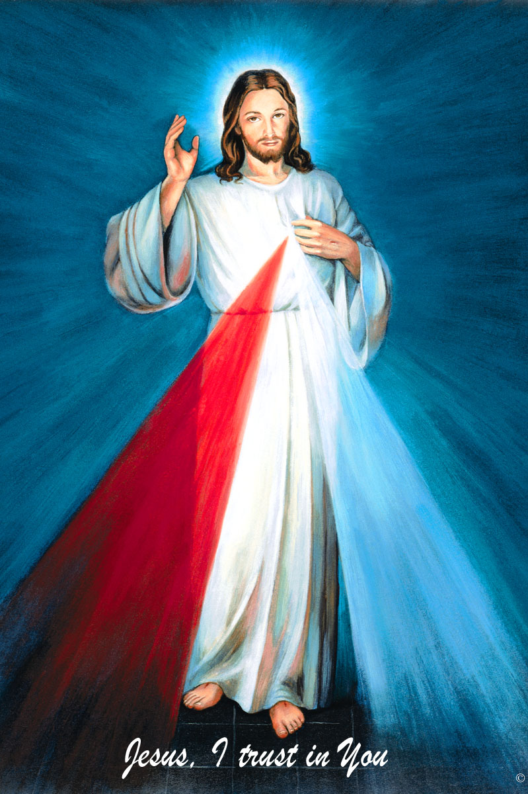
The Divine Mercy Chaplet
and Rosary are prayed
every day at 11:45 in our
Divine Mercy and
Blessed John Paul II Chapel
before our 12:10 Noon Mass.
Please come and
spend time with Jesus!

Immaculate Conception, Marlow News:
Stations of the Cross on
Thursdays of Lent at 6:30 p.m.
Pot Luck Soup Supper following.

Friday Fish Fries During Lent, 5:30-7:30 p.m.
$9.00 for Adults, Children under 12 eat free!

Healing Mass with Anointing of the Sick
Tuesday, March 11 at 7 p.m.at Assumption

NEW on Catholic Radio KKNG 97.3


Spring Forward!!! Don't forget to set your clocks forward Sunday March 9!
Abuse of Minors Pastoral Response Hotline 405-720-9878 You may also contact Oklahoma Department of Human Services at 1-800-522-3511.
Línea Telefónica Pastoral para Reportar Abuso de Menores 405-720-9878 También puede comunicarse con el Departamento de Servicios Humanos al 1-800-522-3511.

Duncan Altar Society News:
The Altar Society Gift Shop has many new tems! Religious articles for First Communion, Confirmation, birthdays, anniversaries and even Easter baskets!

ATTENTION: Altar Society Meeting, Thursday, March 6 after the 12:10 Mass! Bring a dish to share and a friend!!!

!!!Religious Education News!!!
Grades 1-8 meet Wednesdays 6:00-7:15 pm
Grades 9-12 meet Sundays 5:00-6:15 p.m.
Parents: for their safety
your children must be signed in and out!

Attention: No Classes:
Wednesdays March 5 and 19
Sunday, March 16

First Communion: Sunday, May 4
Confirmation: Friday May 16

Nearly a half-million people in need received assistance finding stable housing by turning to their local Catholic Charities agency last year. To learn more, visit www.CatholicCharitiesUSA.org

Catholic Foundation Scholarships Available
The 2014-2015 Catholic Foundation of Oklahoma Scholarship Applications are now available. If interested, please visit the website at www.cfook.org. You may call at 405-721-4115 or mmills@achokc.org. Completed applications are due no later than Tuesday, April 1, 2014.

ATTENTION:
We have renewed the contract on our
Billboard on Highways 81 & 7!
We're looking for sponsors!
The cost is $285.00 per month.
Call the office if you're interested!

Attention
Choir Practice Schedule
Thursdays 7:00 - 8:15 p.m.
We invite those interested in singing in the Choir to join us for practice
in the Choir Loft!
Choir Review will be:
3:00-3:30 p.m. Saturdays
9:00-9:30 a.m. Sundays


Spud Lunch
Tuesday, March 4,
First United Methodist Church
11 a.m.-1:30 p.m.
$7.00 per person
There are no tickets sold at the door.
Contact Dottie Lara for tickets 255-9423.
Please remember you can support
your Church with automatic donations!
Sign up today to automatically donate
your Sunday offering especially
during vacation times!
In order for us to process your automatic donation, we will need from you: voided check and a signed authorization form. Please come to the office after one of our weekend Masses or during the week. For those of you that would like to increase your automatic donations please let us know. We encourage you to sign up for automatic donations if you haven't already!

Saint Patrick Catholic Church
THIRD AND OHIO POST OFFICE BOX 151
Walters, Oklahoma 73572
**************************************
Collections:
Feb 16: Operating: $415.00
Building: $20.00

DUNCAN COLLECTIONs FOR
february 16:
Duncan: $2,680.05
Weekly Direct Deposit Donations: $1,100.00
Building: $85.00
Food Bank: $75.49
St. Vincent de Paul: $85.00
Easter Flowers $394.25
Ryan $190.00

Please remember your Parish in your will.

