Sixth Sunday in Ordinary Time
February 16, 2014

Mass Intentions / Peticiones de Misa MisaMisa

Adult Study with Fr. Peter,
"Introduction to the
Old and New Testament."
Come Learn How the Bible Came to Be!
Mondays , March 3, 10, 17 & 24
at 6:30 p.m. in Gillespie Hall.
Please bring your Bibles and a friend!
Sat | Feb 15 | 4:00p D | (+) Deceased Members of the  The Maier Family
 |  | 6:00p R | (+)Norma, Bill & Neal Corpening
Sun | Feb 16 | 8:00a M | (+)Norma, Bill & Neal Corpening
 |  | 10:00a D | (+)Joseph Pham Van Pham by Jim & Agnes Surjaatmadja
 |  | 12:00p W | For the Parishioners
 |  | 2:00p D | (+)Catherine, Edward & Josephine | We would like to invite everyone to attend a Good-bye Party for Fr. Joseph on Sunday, June 30 at 5 p.m. in Gillespie Hall. The Knights of Columbus are providing hamburgers and hot dogs. We will have a money tree for Fr. Joseph.  We would like to invite everyone to attend a Good-bye Party for Fr. Joseph on Sunday, June 30 at 5 p.m. in Gillespie Hall. The Knights of Columbus are providing hamburgers and hot dogs. We will have a money tree for Fr. Joseph.
Mon | Feb 17 | 12:10p D | Int of Enrique Meza & Family
Tues | Feb 18 | 12:10p D | (+)Joseph Pham Van Pham  Ash Wednesday Service  Assumption Church, Duncan  Wednesday, March 5  7 a.m.  12:10 p.m.  7 p.m.
Wed | Feb 19 | 12:10p D | (+)Roberto Quant
Thur | Feb 20 | 12:10p D | (+)George E. Coughlin
Fri | Feb 21 | 12:10p D | Int of Puresa & John Paul Bazan | In memory of your deceased loved ones please have a  Mass offered for them.  Contact the office for days and times that you wish to have the  Mass celebrated.  What a precious gift!
Sat | Feb 22 | 4:00p D | (+)Kathleen Capshaw
 |  | 6:00p R | (+)Josephine and Ludvica
Sun | Feb 23 | 8:00a M | (+)Joseph Lockovich by  The Pittman Family
 |  | 10:00a D | (+)Jo Ann McCoy by Bill McCoy | Second Collection this Weekend!  Starting this weekend until the Holy Week we will be taking a Second Collection for Easter flowers, decorations and children's Easter Egg Hunt. Thank you for your generosity.  FIRST FRIDAY ADORATION  ADORACIÓN _{DEL} 1er VIERNES  August 2  from 12:30 pm (after mass) - 9 pm  Benediction will be from 8:45 - 9 pm  de 12:30 pm (después de misa) - 9 pm  La Bendición será de 8:45 - 9 pm  FIRST FRIDAY ADORATION  April 5  from 12:30 pm (after mass) - 9 pm  Benediction will be from 8:45 - 9 pm  FIRST FRIDAY ADORATION  April 5  from 12:30 pm (after mass) - 9 pm  Benediction will be from 8:45 - 9 pm
 |  | 12:00p W | For the Parishioners
 |  | 200p R | For God's Blessings for  Paul & Kolleen | FIRST FRIDAY ADORATION  ADORACIÓN _{DEL} 1er VIERNES  August 2  from 12:30 pm (after mass) - 9 pm  Benediction will be from 8:45 - 9 pm  de 12:30 pm (después de misa) - 9 pm  La Bendición será de 8:45 - 9 pm
You can have a Mass said for someone's intentions at their birthday, wedding, baptism, or in memory of your deceased loved ones. Contact the office for days and times that you wish to have
the Mass celebrated.
What a precious gift!

Save the Date:
Sunday March 2, 2014 at 4 p.m.
World Day of Prayer
Celebrating Consecrated Life
Where: Chapel of the
Catholic Pastoral Center
Archbishop Coakley invites you to pray Vespers with him at 4 p.m. to celebrate this important event in the
life of the Church.

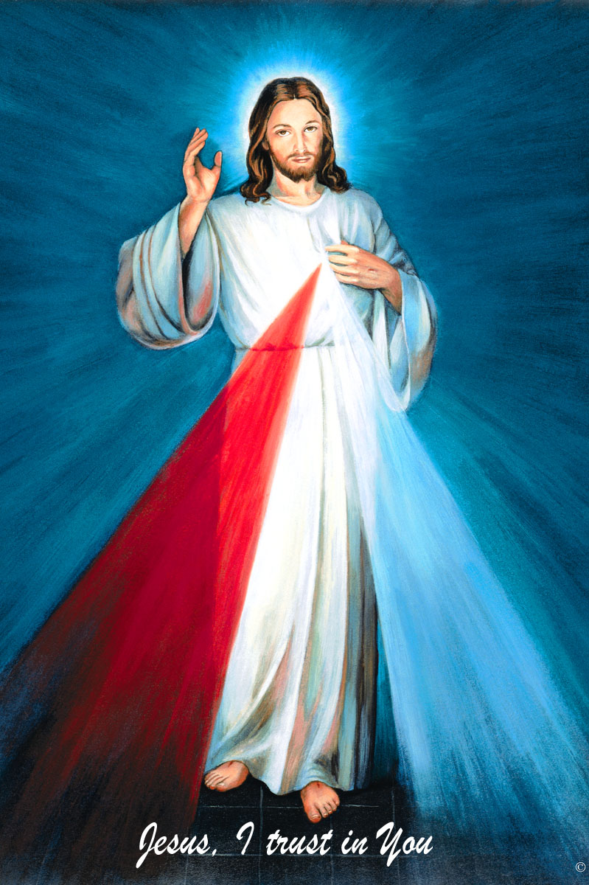
The Divine Mercy Chaplet
and Rosary are prayed
every day at 11:45 in our
Divine Mercy and
Blessed John Paul II Chapel
before our 12:10 Noon Mass.
Please come and
spend time with Jesus!

2014 Archdiocesan Development Fund (ADF) Appeal
"Go Make Disciples"
As some of you might know we have begun our ADF appeal. The pamphlets for this Appeal are available in the pews. Thank you for your generosity.

Healing Mass with Anointing of the Sick
Tuesday, March 11 at 7 p.m.at Assumption

NEW on Catholic Radio KKNG 97.3

Abuse of Minors Pastoral Response Hotline 405-720-9878 You may also contact Oklahoma Department of Human Services at 1-800-522-3511.
Línea Telefónica Pastoral para Reportar Abuso de Menores 405-720-9878 También puede comunicarse con el Departamento de Servicios Humanos al 1-800-522-3511.

Duncan Altar Society News:
The Altar Society Gift Shop has
many new items!
Religious articles for First Communion, Confirmation, birthdays, anniversaries and even Easter baskets!

!!!Religious Education News!!!
Grades 1-8 meet Wednesdays 6:00-7:15 pm
Grades 9-12 meet Sundays 5:00-6:15 p.m.
Parents: for their safety
your children must be signed in and out!
Please be on time to
pick up your children!!!

Upcoming Dates:
Children's Mass: Sunday, February 23
R.E. Teacher's Meeting, Sun Feb 23
after 10 a.m. Mass. Lunch is provided.
First Communion: Sunday, May 4
Confirmation: Friday May 16

Pro-Life Event for Oklahoma with
National Speaker Abby Johnson
Wednesday, February 26, 2014 7-9 p.m. at the
Catholic Pastoral Center
Everyone is invited to this special evening to learn more about promoting a culture of life in today's society. Abby is a Pro-Life activist and author of unPLANNED. For more information contact the Office of Family Life at 405/721-8944 or Debbie at dmkrisch@hotmail.com.

Catholic Foundation Scholarships Available
The 2014-2015 Catholic Foundation of Oklahoma Scholarship Applications are now available. If interested, please visit the website at www.cfook.org. You may call at 405-721-4115 or mmills@achokc.org. Completed applications are due no later than Tuesday, April 1, 2014.

ATTENTION:
We have renewed the contract on our
Billboard on Highways 81 & 7!
We're looking for sponsors!
The cost is $285.00 per month.
Call the office if you're interested!

Attention
Choir Practice Schedule
Thursdays 7:00 - 8:15 p.m.
We invite those interested in singing in the Choir to join us for practice
in the Choir Loft!
Choir Review will be:
3:00-3:30 p.m. Saturdays
9:00-9:30 a.m. Sundays

Spud Lunch
Tuesday, March 4,
First United Methodist Church
11 a.m.-1:30 p.m. $7.00 per person
There are no tickets sold at the door.
Contact Dottie Lara for tickets
255-9423.
Please remember you can support
your Church with automatic donations!
Sign up today to automatically donate
your Sunday offering especially
during vacation times!
In order for us to process your automatic donation, we will need from you: voided check and a signed authorization form. Please come to the office after one of our weekend Masses or during the week. For those of you that would like to increase your automatic donations please let us know. We encourage you to sign up for automatic donations if you haven't already!

Saint Patrick Catholic Church
THIRD AND OHIO POST OFFICE BOX 151
Walters, Oklahoma 73572
**************************************
Collections:
Feb 9: Operating: $726.50
Building: $507.00

DUNCAN COLLECTIONs FOR
february 9:
Duncan: $3,801.00
Weekly Direct Deposit Donations: $1,100.00
Building: $165.00
Food Bank: $60.00
St. Vincent de Paul: $90.00
Scholarship Fund: $15.00
Ryan $314.00

Please remember your Parish in your will.

