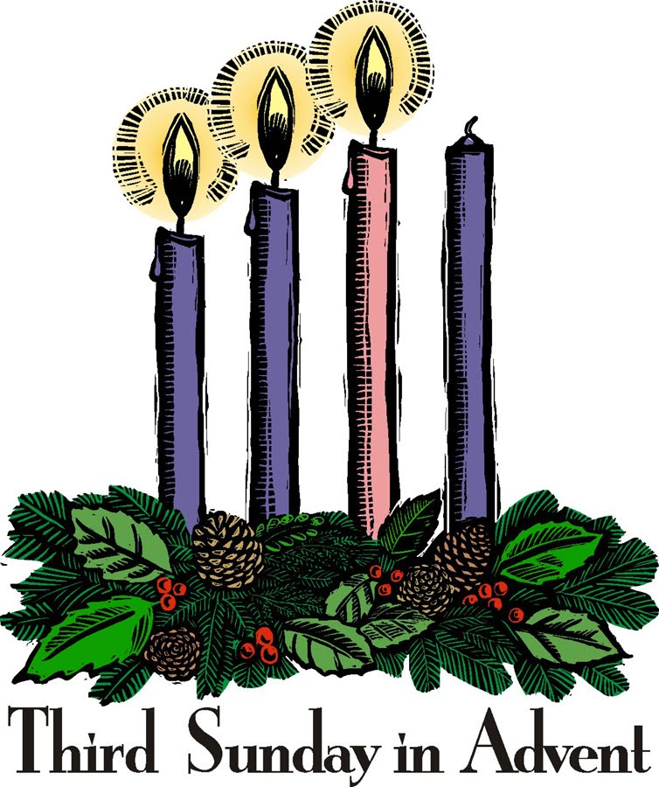
Third Sunday of Advent
December 15, 2013

Mass Intentions / Peticiones de Misa

The office will be closed in observance of Christmas and New Years
Mon, Dec 23 through Wed, Jan 1!

Sat | Dec 14 | 4:00p D | (+)Don Trostle/Jake Seratte
 |  | 6:00p R | For the Parishioners
Sun | Dec 15 | 8:00a M | (+)Fr. Joseph's Father  Christmas Mass Schedule:  Christmas Eve, Tuesday, December 24,  4 pm Marlow  4 pm Walters  6 pm Duncan  12 Midnight Duncan  Christmas Day, Wednesday, December 25  10 am Duncan  10 am Ryan
 |  | 10:00a D | (+)Gloria Roys
 |  | 2:00p D | Int of Ann & Shirley Jean
 |  | 5:00p W | Int of Sarah & Mary | We would like to invite everyone to attend a Good-bye Party for Fr. Joseph on Sunday, June 30 at 5 p.m. in Gillespie Hall. The Knights of Columbus are providing hamburgers and hot dogs. We will have a money tree for Fr. Joseph.  We would like to invite everyone to attend a Good-bye Party for Fr. Joseph on Sunday, June 30 at 5 p.m. in Gillespie Hall. The Knights of Columbus are providing hamburgers and hot dogs. We will have a money tree for Fr. Joseph.
Mon | Dec 16 | 12:10p D | Int of LaVergne Winnett
Tues | Dec 17 | 12:10p D | Int of Jim Martin Boswell
Wed | Dec 18 | 12:10p D | (+)Virginia Hufnagel by Jim
Thur | Dec 19 | 12:10p D | Int of Sisneros Family | FIRST FRIDAY ADORATION  ADORACIÓN _{DEL} 1er VIERNES  August 2  from 12:30 pm (after mass) - 9 pm  Benediction will be from 8:45 - 9 pm  de 12:30 pm (después de misa) - 9 pm  La Bendición será de 8:45 - 9 pm  FIRST FRIDAY ADORATION  April 5  from 12:30 pm (after mass) - 9 pm  Benediction will be from 8:45 - 9 pm  FIRST FRIDAY ADORATION  April 5  from 12:30 pm (after mass) - 9 pm  Benediction will be from 8:45 - 9 pm
Fri | Dec 20 | 12:10p D | Int of Louis & Christine
Sat | Dec 21 | 4:00p D | Int of Severine Pinto | Come decorate the Church for  Christmas Masses on  Sunday, Dec 22  at 3 p.m.  We need your help!  FIRST FRIDAY ADORATION  ADORACIÓN _{DEL} 1er VIERNES  August 2  from 12:30 pm (after mass) - 9 pm  Benediction will be from 8:45 - 9 pm  de 12:30 pm (después de misa) - 9 pm  La Bendición será de 8:45 - 9 pm
 |  | 6:00p R | For the Parishioners
Sun | Dec 22 | 8:00a M | (+)Virginia Hufnnagel by Jim
 |  | 10:00a D | Int of Catherine & John Laico
 |  | 12:00p W | Int of Leoncio, Ed, Ruben & Ian
 |  | 200p R | Int of Alejandro Rodriguez by the ESL Class
Choir Practice Saturday at 2 p.m. and
Sunday Choir Review at 8:45 a.m.
We invite those interested in singing in the Choir to join us for practice in the Choir Loft!\

Children's Christmas Choir Practice on:
Sunday, Dec 15 at 3 p.m.
Wednesday, Dec 18 at 5 p.m.
Sunday, Dec 22 at 7 p.m.

St. Nicholas Celebration,
has been moved to Wednesday, Dec 18
6-7:30 p.m.
In honor of St. Nicholas,
"The Real Santa" we will be having a fun day
for the kids of our Duncan Parish, and
Missions: Marlow, Ryan and Walters.
All kids are invited!
Come eat dinner, play games and win prizes! Parents are invited to help!
If you would like to make a donation
to cover the costs please mark,
"St. Nicholas Day" on your check or place cash in an envelope marked, "St Nicholas Day".
If you would like to help with anything or have any ideas please call the office.
Invitación a TODOS los niños! y TODOS los familiares están invitados a traer ideas o ayudar a celebrar el día de San Nicolás
que será el día Miércoles 18 de diciembre de
6-7:30p.m.
Esta celebración es en honor de
San Nicolás El verdadero “Santa”
para todos los niños las parroquias de
Duncan, Marlon, Ryan, y Walter.
Vengan a comer, jugar, y ganar premios! Si les gustaría dar una donación para cubrir los gastos en su cheque háganlo para la iglesia y anote que será para “St. Nicholas Day" y póngalo en el sobre marcado, "St. Nicholas Day".

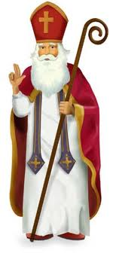

A note of "THANK YOU" to the Pastor and Parishioners of Assumption of the Blessed Virgin Mary Church, Immaculate Conception, San Jose and St Patrick from the Monks of St. Gregory's Abbey and the Faculty, Staff and Students of St. Gregory's University for allowing one of the Benedictine Monks to speak in your parish and your generosity to the Catholic Scholarship Fund. A total of $1,244.16 was received.

Don't forget the Holiday Food Fund!
There are envelopes in the pews.

405-720-9878 Abuse of Minors Pastoral Response Hotline 405-720-9878 You may also contact Oklahoma Department of Human Services at 1-800-522-3511.
405-720-9878 Línea Telefónica Pastoral para Reportar Abuso de Menores 405-720-9878También puede comunicarse con el Departamento de Servicios Humanos al 1-800-522-3511.

Duncan Altar Society News:

Annual Christmas Bake Sale
after weekend Masses
Saturday & Sunday December 21-22
Come support the Altar Society
and buy your holiday goodies!

!!!Religious Education News!!!
Grades 1-8 meet Wednesdays 6:00-7:15 pm
Grades 9-12 meet Sundays 5:00-6:15 p.m.
Parents: for their safety
your children must be signed in and out!
Please be on time to pick up your children!!!

Attention Parents:
Christmas Break - No Classes on:
Sundays, Dec 22, 29 and Jan 5
Wednesdays, Dec 25 and Jan 1

Father Peter Jandaczek to celebrate Polish Mass
Fr. Peter will celebrate a Polish Mass at 4 p.m., Saturday, December 21 at Saint Teresa of Avila Catholic Church, 1576 Tim Holt Drive in Harrah, OK. Fr. Jaroslow Topolewski, pastor of St Anthony of Padua Church in Okeene and Fr. Prakash Madineni, pastor of St Teresa of Avila Church in Harrah will concelebrate. For more information please call 405-454-2819.

Attention: If you're interested in serving on Assumption's Parish Council please
send us your bio and the
reason you want to serve via e-mail.

Want to Meet other Youth?

Join Assumption's YOUTH GROUP!!!
Youth grades 7-12 are invited to come join us for faith,
games and socializing!
Meetings are every SUNDAY in the R.E. Auditorium Building
from 6:20-8:00 p.m.
For more information contact Youth Coordinator
Armando at 405/779-0285.
Unirse a grupo de jóvenes supuesto!!!
Los jóvenes los grados 7-12 están invitados a
unirse a nosotros por la fe, juegos y socializar. Las reuniones son todos los domingos a partir de septiembre 29 en el R. E. Auditorio del Edificio de 6:20 -8:00 p.m. para obtener más información, póngase en contacto con Coordinador de la Juventud
Armando en 405/779-0285.

Duncan Area Literacy Council is sponsoring English as a Second Language Classes at our Parish. The classes are taking place twice a week on Tuesday and Thursday mornings from 10-11 a.m. at the R.E. Bldg. For more information call 580-736-1170.
El Consejo de Alfabetizacion de Duncan ofrecera clases de ingles en R. E Bldg. Las clases seran los martes y jueves por la manana de 10-11 a.m.

Interested in Becoming Catholic
and joining our Church?
The "Rite of Christian Initiation of Adults" (RCIA) is a spiritual instructional and ritual process for adults. Those adults wishing to become a member of the Catholic Church through the Sacraments of Baptism, Confirmation and Eucharist are welcome and encouraged to inquire about the RCIA Sessions. We meet on Tuesday evenings at 7 p.m. in the Religious Education Building Parish Hall. Please contact Mike Radtke (606-0283) for information.
Please remember you can support
your Church with automatic donations!
Sign up today to automatically donate
your Sunday offering especially during vacation times!
In order for us to process your automatic donation, we will need from you: voided check and a signed authorization form. Please come to the office after one of our weekend Masses or during the week.

DUNCAN COLLECTIONs FOR
December 8:
Duncan: $1,816.21
Building: $25.00
Holiday Food Fund: $37.00
Weekly Direct Deposit Donations: $1,100.00

You are invited to a concert by Cristiano Rizzotto, who plays the organ for Duncan Masses. The Concert will be at the First Presbyterian Church, 1302 SW "A", Lawton on Sunday, Dec 22 at 4 p.m.
Please remember your Parish in your will.

