Thirty-Third Sunday in Ordinary Time
November 17, 2013

Christmas Mass Schedule:
Christmas Eve, Tuesday, December 24,
4 pm Marlow
4 pm Walters
6 pm Duncan
12 Midnight Duncan
Christmas Day, Wednesday, December 25
10 am Duncan
10 am Ryan
Mass Intentions / Peticiones de Misa

Sat | Nov 16 | 4:00p D | Int of Howard Doerr by  Wolfgang Deeg Family
 |  | 6:00p R | (+)Don Boice
Sun | Nov 17 | 8:00a M | For Fr. Joseph's Father by  Ann & Troy
 |  | 10:00a D | (+)Don Boice
 |  | 12:00p W | Charles Fowler by Rocky & Nita Eveland  There is a Healing Mass, Tuesday, November 19 at 7 p.m. at Assumption!
 |  | 2:00p D | For the Parishioners | We would like to invite everyone to attend a Good-bye Party for Fr. Joseph on Sunday, June 30 at 5 p.m. in Gillespie Hall. The Knights of Columbus are providing hamburgers and hot dogs. We will have a money tree for Fr. Joseph.  We would like to invite everyone to attend a Good-bye Party for Fr. Joseph on Sunday, June 30 at 5 p.m. in Gillespie Hall. The Knights of Columbus are providing hamburgers and hot dogs. We will have a money tree for Fr. Joseph.
Mon | Nov 18 | 12:10p D | Rev. James Greiner by His Parish  Parish Thanksgiving Dinner  Sunday, Nov 24 at  Assumption's Auditorium  Dinner is served at 3 p.m.  The Sponsors are the  Knights of Columbus.  There will be a dessert auction to follow dinner and items supplied by the Altar Society. There is no cost for the dinner and the Knights of Columbus and Altar Society wish to show their appreciation to all parishioners for supporting their activities this past year.
Tues | Nov 19 | 12:10p D | 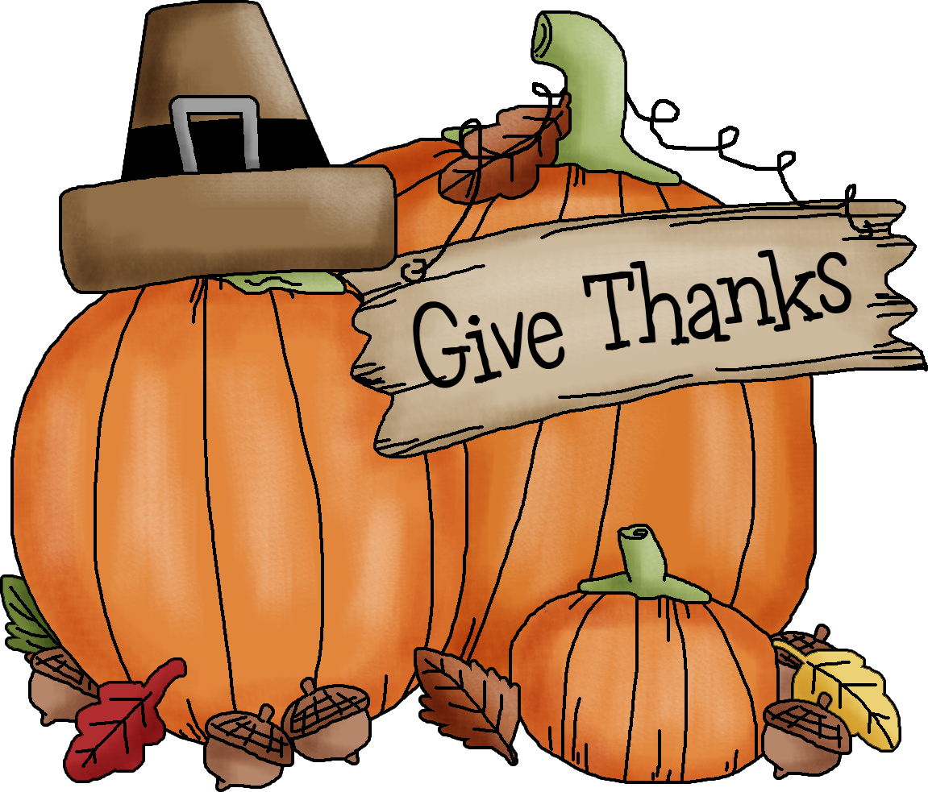(+)Gloria Roys by Ann Boice
Wed | Nov 20 | 12:10p D | (+)Joe Lockovich by Ann Boice | FIRST FRIDAY ADORATION  ADORACIÓN _{DEL} 1er VIERNES  August 2  from 12:30 pm (after mass) - 9 pm  Benediction will be from 8:45 - 9 pm  de 12:30 pm (después de misa) - 9 pm  La Bendición será de 8:45 - 9 pm  FIRST FRIDAY ADORATION  April 5  from 12:30 pm (after mass) - 9 pm  Benediction will be from 8:45 - 9 pm  FIRST FRIDAY ADORATION  April 5  from 12:30 pm (after mass) - 9 pm  Benediction will be from 8:45 - 9 pm
Thur | Nov 21 | 12:10p D | Pacello Family & Friends
Fri | Nov 22 | 12:10p D | (+)Don Dowhower by Rose Cox | FIRST FRIDAY ADORATION  ADORACIÓN _{DEL} 1er VIERNES  August 2  from 12:30 pm (after mass) - 9 pm  Benediction will be from 8:45 - 9 pm  de 12:30 pm (después de misa) - 9 pm  La Bendición será de 8:45 - 9 pm
Sat | Nov 23 | 4:00p D | Ray & Shirley Cielencki
 |  | 6:00p R | For the Parishioners
Sun | Nov 24 | 8:00a M | (+)Pedro Martinez by Alicia
 |  | 10:00a D | (+)Fr. Joseph's Father by  Carrie & David
 |  | 12:00p W
 |  | 2:00p D
You're Invited to St. Patrick's Church in Walters for a Note Burning Party and Mass of thanksgiving for paying off their New Parish Hall debt on Sunday December 15 at 5 p.m. Please note there will be no 12 noon Mass. A potluck supper will be shared after the Mass. Please bring a dish to share.
The Memorial Mass for Joe Lockovich will be on
Tuesday, November 19 at 10 a.m. at
Immaculate Conception Church in Marlow.

This weekend there will be a special second collection for the victims of Typhoon Haiyan in the Philippines and Vietnam. Please be generous!

Platicas del Sacramento de Bautizmo en Español
del año 2013 Serań en: Noviembre 30.
Son a la 7 p.m. en La capilla.
Para mas informacioń llame a la oficina
580-255-0590 ex 11, o Carmen Garcia
580-255-6337 Gracias.
The weekend of Nov 30-Dec 1 a representative from St. Gregory's will be speaking at Masses and a second collection will be taken up for the St. Gregory's University.

Interested in Becoming Catholic
and joining our Church?
The "Rite of Christian Initiation of Adults" (RCIA) is a spiritual instructional and ritual process for adults. Those adults wishing to become a member of the Catholic Church through the Sacraments of Baptism, Confirmation and Eucharist are welcome and encouraged to inquire about the RCIA Session starting soon. Please contact Mike Radtke (606-0283) for information on participating in this Rite.
Attention: If you're interested in serving on Assumption's Parish Council please send us your bio and the reason you want to serve via e-mail.

Music Heals the Heart: A Benefit Concert
for the Father Roberto Quant
Education Scholarship Fund
When: 7 p.m., Friday, December 6
Where: Saint James the Greater Catholic Church, 4201 South McKinley Avenue, Oklahoma City, 73109
Why: To raise money for the Father Roberto Quant scholarship fund, which helps students receive a Catholic education at Sacred Heart School.
Ticket prices: Suggested donation of $10. To obtain a ticket, call Principal Joana Camacho’s office at (405) 634-5673.

Duncan Area Literacy Council is sponsoring English as a Second Language Classes at our Parish. The classes are taking place twice a week on Tuesday and Thursday mornings from 10-11 a.m. at the R.E. Bldg. For more information call 580-736-1170.
El Consejo de Alfabetizacion de Duncan ofrecera clases de ingles en R. E Bldg. Las clases seran los martes y jueves por la manana de 10-11 a.m.

405-720-9878 Abuse of Minors Pastoral Response Hotline 405-720-9878 You may also contact Oklahoma Department of Human Services at 1-800-522-3511.
405-720-9878 Línea Telefónica Pastoral para Reportar Abuso de Menores 405-720-9878También puede comunicarse con el Departamento de Servicios Humanos al 1-800-522-3511.

!!!Religious Education News!!!
Grades 1-8 meet Wednesdays 6:00-7:15 pm
Grades 9-12 meet Sundays 5:00-6:15 p.m.
Parents: for their safety
your children must be signed in and out!
Please be on time to pick up your children!!!
ATTENTION PARENTS: No R.E. Classes on Sun, Nov 24 and Wed, Nov 27 because of the Thanksgiving Holiday!

--R.E. Teachers Meeting Sunday, December 1
at 11:30 lunch will be provided!

Duncan Altar Society News:
"Keep Christ in Christmas"
Assumption Catholic Church Christmas Bazaar 711 W Hickory Ave
Saturday, November 23-10:00 a.m. - 6:00 p.m.

Crafts, baked goods, Christian articles,
gifts and books.
Refreshments and Mexican food for sale.
Something for everyone.
Do your Christmas shopping early!
Ladies: all the craft items that you are making for the Christmas Bazaar need to be brought to the Church by Thursday, November 21
so we can get them priced.
We also need gift bags to put the merchandise in.
Baked goods can be brought in Saturday morning, November 23 by 9:00 a.m.!


St. Nicholas Day Celebration,
Saturday, December 7 @ 5-9 p.m.
In honor of St. Nicholas,
"The Real Santa" we will be having a fun day
for the kids of our Duncan Parish, and
Missions: Marlow, Ryan and Walters.
Come to Mass @ 4 p.m. Saturday
and after the Mass in Duncan there will be a
St. Nicholas Day Celebration.
All kids are invited!
Come eat dinner, play games and win prizes! Parents are invited to help!
If you would like to make a donation
to cover the costs please mark,
"St. Nicholas Day" on your check or place cash in an envelope marked, "St Nicholas Day".
If you would like to help with anything or have any ideas please call the office.

Invitación a TODOS los niños!
y TODOS los familiares están invitados a traer ideas o ayudar a celebrar el día de San Nicolás
que será el día Sábado 7 de diciembre de 5-8p.m.
Esta celebración es en honor de
San Nicolás El verdadero “Santa”
para todos los niños las parroquias de
Duncan, Marlon, Ryan, y Walter.
La celebración empezara
después de la misa de las 4:00 p.m.
en Duncan. Vengan a comer, jugar, y ganar premios! Si les gustaría dar una donación para cubrir los gastos en su cheque háganlo para la iglesia y anote que será para “St. Nicholas Day" y póngalo en el sobre marcado, "St. Nicholas Day".

Choir Practice
Saturday at 2 p.m. and Sunday at 8:45 a.m.
We invite those interested in singing in the Choir to join us for practice in the Choir Loft!

Want to Meet other Youth?

Join Assumption's YOUTH GROUP!!!
Youth grades 7-12 are invited to come join us for faith,
games and socializing!
Meetings are every SUNDAY in the R.E. Auditorium Building
from 6:20-8:00 p.m.
For more information contact
Youth Coordinator Armando at 405/779-0285.
Unirse a grupo de jóvenes supuesto!!!
Los jóvenes los grados 7-12 están invitados a
unirse a nosotros por la fe, juegos y socializar. Las reuniones son todos los domingos a partir de septiembre 29 en el R. E. Auditorio del Edificio de
6:20 -8:00 p.m. para obtener más información, póngase en contacto con Coordinador de la Juventud
Armando en 405/779-0285.



Please remember your Parish in your will.
Saint Patrick Catholic Church
THIRD AND OHIO POST OFFICE BOX 151
Walters, Oklahoma 73572
**************************************
A very special THANK YOU to the
Knights of Columbus for the beautiful flag
donated to St. Patrick Church.
Fr. Peter and the Knights made the dedication a very special occasion! God Bless You!
Collections:
Nov 3: Operating: $1,090.00 Bldg: $274.00
Nov 10: Operating $575.69

DUNCAN COLLECTIONs FOR
November 10:
Duncan: $2,261.62
Building: $370.00
Ryan: $181.00
Weekly Direct Deposit Donations: $1,100.00

Please remember you can support
your Church with automatic donations!
Sign up today to automatically donate
your Sunday offering especially during vacation times!
In order for us to process your automatic donation, we will need from you: voided check and a signed authorization form. Please come to the office after one of our weekend Masses or during the week.

