Nineteenth Sunday in Ordinary Time
August 12, 2018

The Parish Feast of the
Assumption of the
Blessed Virgin Mary is Wednesday, August 15, 2018. at 7 p.m.
In Duncan only one Mass.
Mass Intentions / Peticiones de Misa

Sat | Aug11 | 4:00p D
 |  | 6:00p R
Sun | Aug 12 | 8:00a M | Int of Janice Duesman Payne
 |  | 10:00a D | (+) Brenda Lee Plumlee  By Pat Cook
 |  | 12:00a W
 |  | 2:00p D | NO SPANISH MASS
Mon | Aug 13 | 12:10p D | For the Parishioners
Tues | Aug 14 | 12:10p D | (+) Don Trostle & Jake Seratte
Wed | Aug 15 | 7:00p D | (+) Mary Douchinsky
Thur | Aug 16 | 12:10p D
Fri | Aug 17 | 12:10p D | For the Parishioners
Sat | Aug 18 | 4:00p D
 |  | 6:00p R
Sun | Aug 19 | 8:00a M | (+) Delores Havron  By Bill & Kathi Havron
 |  | 10:00a D | (+) Amanda Chavez
 |  | 12:00p W
 |  | 2:00p D | NO SPANISH MASS
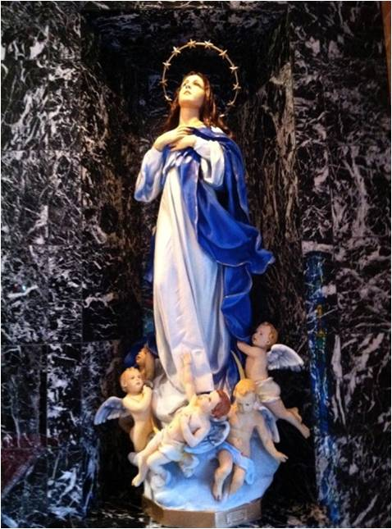

ATTENTION: There will be NO 2 pm Spanish Masses
Sundays, Aug 12th and 19th

Special Collection for Property and Liability Insurance BALANCE TO COLLECT: $4,000.00
Every Sunday we will be having a Second Collection
for our Property and Liability Insurance for the year
2018/2019 which is around $19,000.00.
Therefore, we request that you help $15,000.00
us to raise money for this necessary expenditure.
Please write checks to
Assumption/Building Fund. $5,000.00
Thank you for your generosity.
May God Bless You, Fr. Peter $2,000.00

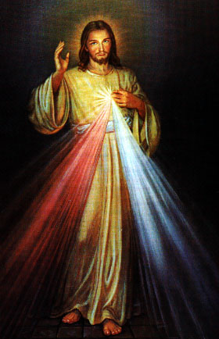
Abuse of Minors Response Hotline 405-720-987 or DHS at 1-800-522-3511.
Telefóno Pastoral para Reportar Abuso de Menores 405-720-9878 o el Departamento de Servicios Humanos 1-800-522-3511.

Third Annual Christmas Bazaar
November 20, 21 and 22
Attention: There will be a work day on Saturday, October 10 at 10 a.m. in Gillespie Hall! We need your ideas! It will take all of us participating to make our Bazaar a success!!!

Eggrolls by Agnes, order now.
She will only make 20 dozen.
They are $40 per dozen.
Pick up will be Friday, October 16.
Place order and pay at the office.

Order Tamales by Carmen
at $25.00 per dozen.
Order and pay at the office.
Pick up will be
Saturday, Nov 14.

The profit will equally be divided between three Parishes: Walters, Duncan and Marlow for the purpose of the building fund. We need your time, talent and treasure to make this event successful.

