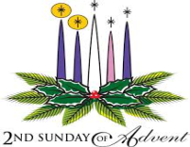
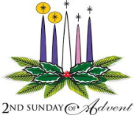
Second Sunday of Advent
December 10, 2017
Sep[t, 2017

Mass Intentions / Peticiones de Misa

Sat | Dec 9 | 4:00p D | (+) Sylvester Woodridge (G)  Religious Education (RE) Families:  Please note the following dates:  Class times are as follows:  Grades 1-6 meet on Wednesday  from 6:00pm-7:30pm  Grades 7-12 meet on Sunday  from 11:00pm-12:30pm  Please drop the children off on time  and pick up promptly!  For any questions or concerns regarding Religious Education you may reach me at maria.martinez@yahoo.com or you may call the church office and leave a message.  Maria Martinez, RE Director
  Sunday, Dec 10 | Class
  Wednesday, Dec 13 | Class
  Dec 17-Jan 3 | NO CLASSES  Christmas Break
  January 7 & 10, 2018 | CLASSES RESUME
 |  | 6:00p R | (+) Pedro Martinez by Alicia
Sun | Dec 10 | 8:00a M | (+) Sylvester Wooldridge (G) | Christmas Bazaar  Our Christmas Bazaar  will be held  November 18, 19 and 20.  We hope everyone is making  beautiful items for sale.  There will also be a raffle for  three Visa cards:  $1,000, $500 and $250!  The raffle tickets are for sale now!  They are $5.00 each or five for $20.00! Please buy tickets and  also check them out to sell.  Let’s come together and  work hard to make this a  successful event!
 |  | 10:00a D | (+) Pedro Martinez by Alicia
 |  | 12:00p W
 |  | 7:00p D
Mon | Dec 11 | 12:10p D | Happy Birthday Anna Fitts
 |  |  | (+) Sylvester Woodridge (G)
Tues | Dec 12 | 12:10p D | (+) Sylvester Woodridge (G)
Wed | Dec 13 | 12:10p D | (+) Sylvester Woodridge (G)
Thur | Dec 14 | 12:10p D | (+) Sylvester Woodridge (G)
(+) Don Trostle & Jake Seratte
by the Family
Fri | Dec 15 | 12:10p D | (+) Sylvester Woodridge (G)
Sat | Dec 16 | 4:00p D | (+) Sylvester Woodridge (G)
 |  | 6:00p R | Living & Deceased Members of the Altar Society
Sun | Dec 17 | 8:00a M | (+) Sylvester Woodridge (G)
 |  | 10:00a D | (+) Pham Pham Joseph  by the Family
 |  | 12:00p W
 |  | 2:00p D | (+) Maria Oliva Perez  by the Altar Society

la fiesta de La
VIRGEN DE GUADALUPE

Todos están invitados a la celebración anual
de la Virgen de Guadalupe y retiro de Adviento con Padre Iden Bello!

10 de Diciembre, Domingo:
7 p.m. la Misa
11 de Diciembre Lunes:
7p.m. Adoración y predica
11p.m. Mañanitas
Medianoche La Misa de la Virgen
12 de Diciembre:
6p.m. Rosario---7:30 p.m. Cena

Our lady of Guadalupe celebration

Everyone is invited to the
annual celebration
of the Virgin of Guadalupe!

Sunday December 10: 7 p.m. Mass
Monday, December 11,
7 p.m. Adoration
11:00 p.m. Mananitas
Midnight Mass
Tuesday, December 12
6:00 pm ------------------ Rosary
7:30pm --------------- Dinner

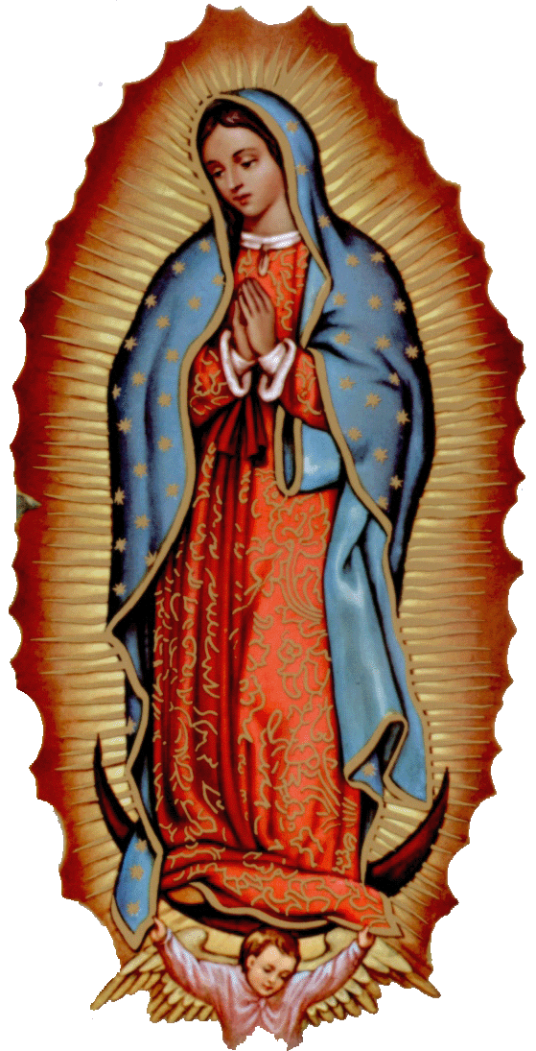
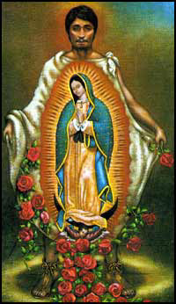

Third Annual Christmas Bazaar
November 20, 21 and 22
Attention: There will be a work day on Saturday, October 10 at 10 a.m. in Gillespie Hall! We need your ideas! It will take all of us participating to make our Bazaar a success!!!

Eggrolls by Agnes, order now.
She will only make 20 dozen.
They are $40 per dozen.
Pick up will be Friday, October 16.
Place order and pay at the office.

Order Tamales by Carmen
at $25.00 per dozen.
Order and pay at the office.
Pick up will be
Saturday, Nov 14.

The profit will equally be divided between three Parishes: Walters, Duncan and Marlow for the purpose of the building fund. We need your time, talent and treasure to make this event successful.

Mark your calendar for Catholic Foundation’s presentation on wills and trusts. This will be held on Monday, October 24 at 7 p.m. at Assumption Catholic Church Gillespie Hall. Come and learn how to take care of those you love.
You can have a Mass said for someone's intentions at their birthday, wedding, baptism, or in memory of your deceased loved ones. Contact he office for days and times that you wish to have the Mass celebrated. What a precious gift!

Abuse of Minors Response Hotline 405-720-987 or DHS at 1-800-522-3511.
Telefóno Pastoral para Reportar Abuso de Menores 405-720-9878 o el Departamento de Servicios Humanos 1-800-522-3511.


CHRISTMAS
MASS SCHEDULE:

Saturday, December 23
4 p.m. Duncan
4 p.m. Marlow
6 p.m. Walters
No Ryan Mass

Sunday, December 24
10 a.m. Duncan

Christmas Vigil:
4 p.m. Marlow
6 p.m. Walters
6 p.m. Duncan
12 Midnight Mass Duncan
No Ryan Mass

Monday, Christmas Day, December 25
10:00 a.m. Duncan
NO SPANISH MASS

ATTENTION:
THERE WILL BE A
PENANCE SERVICE ON MONDAY, DECEMBER 18 AT 7 P.M.
AT ASSUMPTION PARISH.
ALL ARE INVITED.
Come before the Lord
so He can touch you and heal you!




Immaculate Conception Church
Marlow
**********************************
Collections:
Dec 3: Operating: $868.82
Building: $860.00

DUNCAN COLLECTIONs FOR
Dec 2-3:
Duncan: $1,559.75
Weekly Electronic Donations: $1,200.00
Second Collection: $292.38
St. Vincent de Paul: $23.00
RYAN: $150.00
Thank you for your generosity!!!

Duncan Altar Society
Christmas Bake Sale
Saturday and Sunday,
December 16-17
after all weekend Masses

Bring your items for sale and
plan to purchase wonderful baked
goods for Christmas.
Thank you all!

Saint Patrick Catholic Church
Walters, Oklahoma 73572
********************************
Collections:
Dec 3: Operating $

If you have a Pastoral Emergency please contact 580-786-2098

