
First Sunday of Advent
December 3, 2017
Sep[t, 2017

Mass Intentions / Peticiones de Misa

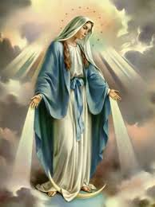

The Feast of Immaculate Conception is Friday, December 8. It is a Holy Day of Obligation as well as Patroness of the United States.
Our Mass schedule will be as follows:
Duncan 12:10 p.m.
Marlow 7:00 p.m.
followed by refreshments

Sat | Dec 2 | 4:00p D | (+) Sylvester Woodridge (G)
 |  | 6:00p R | Intentions of Howard Doerr  By Janet Deeg
Sun | Dec 3 | 8:00a M | (+) Sylvester Wooldridge (G) | Christmas Bazaar  Our Christmas Bazaar  will be held  November 18, 19 and 20.  We hope everyone is making  beautiful items for sale.  There will also be a raffle for  three Visa cards:  $1,000, $500 and $250!  The raffle tickets are for sale now!  They are $5.00 each or five for $20.00! Please buy tickets and  also check them out to sell.  Let’s come together and  work hard to make this a  successful event!
 |  | 10:00a D | (+) Julian Medrano
 |  | 12:00p W
 |  | 2:00p D
Mon | Dec 4 | 12:10p D | (+) Sylvester Woodridge (G)
 |  |  | (+) Jack Geurkink
Tues | Dec 5 | 12:10p D | (+) Sylvester Woodridge (G)
Wed | Dec 6 | 12:10p D | (+) Sylvester Woodridge (G)
Thur | Dec 7 | 12:10p D | (+) Sylvester Woodridge (G)
Fri | Dec 8 | 12:10p D | (+) Sue Morris  by Tom & Edie Stone
 |  | 7:00p M | (+) Sylvester Woodridge (G)
Sat | Dec 9 | 4:00p D | (+) Sylvester Woodridge (G)
 |  | 6:00p R | (+) Pedro Martinez by Alicia
Sun | Dec 10 | 8:00a M | (+) Sylvester Woodridge (G)
 |  | 10:00a D | (+) Pedro Martinez by Alicia
 |  | 12:00p W
 |  | 7:00p D | Spanish Mass
ATTENTION: THE OFFICE WILL BE CLOSED FRIDAY, DECEMBER 8
IN OBSERVANCE OF THE FEAST OF IMMACULATE CONCEPTION.

la fiesta de La
VIRGEN DE GUADALUPE

Todos están invitados a la celebración anual
de la Virgen de Guadalupe y retiro de Adviento con Padre Iden Bello!

10 de Diciembre, Domingo:
7 p.m. la Misa
11 de Diciembre Lunes:
7p.m. Adoración y predica
11p.m. Mañanitas
Medianoche La Misa de la Virgen
12 de Diciembre:
6p.m. Rosario---7:30 p.m. Cena

Our lady of Guadalupe celebration

Everyone is invited to the
annual celebration
of the Virgin of Guadalupe!

Sunday December 10: 7 p.m. Mass
Monday, December 11,
7 p.m. Adoration
11:00 p.m. Mananitas
Midnight Mass
Tuesday, December 12
6:00 pm ------------------ Rosary
7:30pm --------------- Dinner

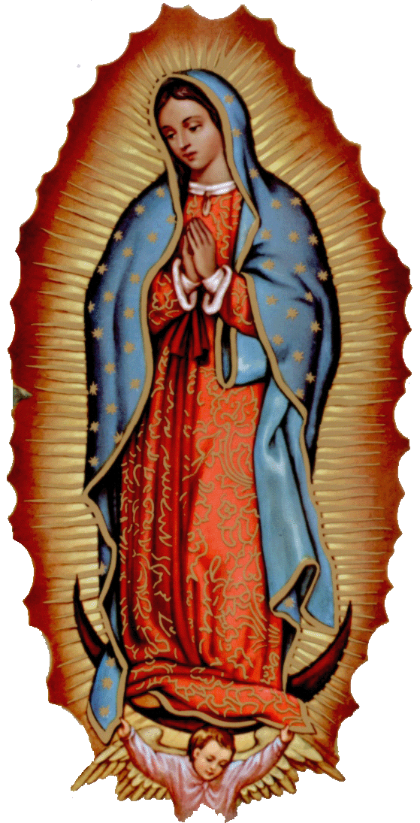
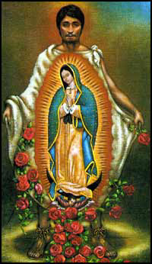

Third Annual Christmas Bazaar
November 20, 21 and 22
Attention: There will be a work day on Saturday, October 10 at 10 a.m. in Gillespie Hall! We need your ideas! It will take all of us participating to make our Bazaar a success!!!

Eggrolls by Agnes, order now.
She will only make 20 dozen.
They are $40 per dozen.
Pick up will be Friday, October 16.
Place order and pay at the office.

Order Tamales by Carmen
at $25.00 per dozen.
Order and pay at the office.
Pick up will be
Saturday, Nov 14.

The profit will equally be divided between three Parishes: Walters, Duncan and Marlow for the purpose of the building fund. We need your time, talent and treasure to make this event successful.

Mark your calendar for Catholic Foundation’s presentation on wills and trusts. This will be held on Monday, October 24 at 7 p.m. at Assumption Catholic Church Gillespie Hall. Come and learn how to take care of those you love.
You can have a Mass said for someone's intentions at their birthday, wedding, baptism, or in memory of your deceased loved ones. Contact he office for days and times that you wish to have the Mass celebrated. What a precious gift!

Abuse of Minors Response Hotline 405-720-987 or DHS at 1-800-522-3511.
Telefóno Pastoral para Reportar Abuso de Menores 405-720-9878 o el Departamento de Servicios Humanos 1-800-522-3511.




Religious Education (RE) Families:
Please note the following dates:
Sunday, Dec 3 | Class
Wednesday Dec 6 | Class
Sunday, Dec 10 | Class
Wednesday, Dec 13 | Class
Dec 17-Jan 3 | NO CLASSES  Christmas Break
January 7 & 10, 2018 | CLASSES RESUME
Class times are as follows:
Grades 1-6 meet on Wednesday
from 6:00pm-7:30pm
Grades 7-12 meet on Sunday
from 11:00pm-12:30pm
Please drop the children off on time
and pick up promptly!
For any questions or concerns regarding Religious Education you may reach me at maria.martinez@yahoo.com or you may call the church office and leave a message.
Maria Martinez, RE Director

CALLING ALL YOUTH!!!

We will meet in the Choir Loft on Wednesdays at 5:00 p.m.
Please contact Cece Bogle at 580-735-3991
for further information.

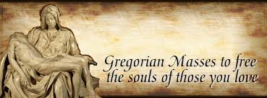

Saint Patrick Catholic Church
Walters, Oklahoma 73572
********************************
Collections:
Nov 26: Operating $874.39

We want to thank everyone who has volunteered in our Annual Christmas Bazaar. We made $28,000.00. This amount will be distributed as follows:
60% which is $16,800.00 to Duncan
25% which is $7,000.00 to Marlow
15% which is $4,200.00 to Walters.

Immaculate Conception Church
Marlow
**********************************
Collections:
Nov 26: Operating: $676.00

You can have Masses offered for
someone’s birthday, wedding, baptism or in memory of your deceased loved ones. Contact the office for days and times that you wish to have the Mass celebrated. What a wonderful spiritual gift!

A Gregorian Mass is for the faithfully departed.
The Holy Mass is said daily for thirty days.

Please come by the office today and offer a Gregorian Mass for your loved one!
DUNCAN COLLECTIONs FOR
November 25-26:
Duncan: $1,985.50
Weekly Electronic Donations: $1,200.00
Second Collection: $245.00
Building Fund: $20.00
St. Vincent de Paul: $15.00
RYAN: $100.00
Thank you for your generosity!!!

If you have a Pastoral Emergency please contact 580-786-2098

