Thirty-Third Sunday in Ordinary Time
November 19, 2017
Sep[t, 2017

The Feast of Immaculate Conception is Friday, December 8. It is a Holy Day of Obligation as well as Patroness of the United States.
Our Mass schedule will be as follows:
Duncan 12:10 p.m.
Marlow 7:00 p.m.
followed by refreshments
Mass Intentions / Peticiones de Misa

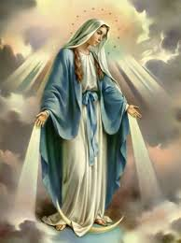

Sat | Nov 18 | 4:00p D | (+) John Park by  Greg & Patty Winegardner
 |  | 6:00p R | (+) Dorothy & Charles Scott
Sun | Nov 19 | 8:00a M | Phil Adams 96th Birthday | Christmas Bazaar  Our Christmas Bazaar  will be held  November 18, 19 and 20.  We hope everyone is making  beautiful items for sale.  There will also be a raffle for  three Visa cards:  $1,000, $500 and $250!  The raffle tickets are for sale now!  They are $5.00 each or five for $20.00! Please buy tickets and  also check them out to sell.  Let’s come together and  work hard to make this a  successful event!
 |  | 10:00a D | (+) Bobbi Elizabeth Mullen Jester
 |  | 12:00p W
 |  | 2:00p D | (+) Dorothy & Charles Scott
Mon | Nov 20 | 12:10p D | (+) Dorothy & Charles Scott
Tues | Nov 21 | 12:10p D | (+) Dorothy & Charles Scott
Wed | Nov 22 | 12:10p D | (+) Dorothy & Charles Scott
Thur | Nov 23 | 12:10p D | NO MASS
Fri | Nov 24 | 12:10p D | NO MASS
Sat | Nov 25 | 4:00p D | (+) Alice Barnes  by Carolyn Trostle
 |  | 6:00p R | (+) Dorothy & Charles Scott
Sun | Nov 26 | 8:00a M | (+) Sylvester Wooldridge
 |  | 10:00a D | (+) Dorothy & Charles Scott
 |  | 12:00p W
 |  | 2:00p D | (+) Carlos Sanchez  by Noe Sanchez

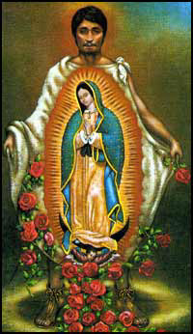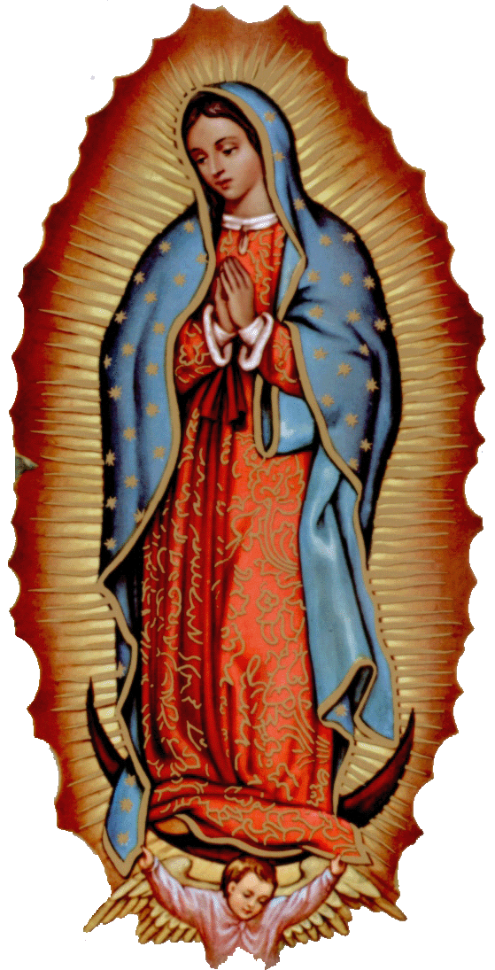
ATTENTION: The office will be closed Tuesday through Friday, November 21-24 in observance of the Thanksgiving holiday.

There will be no Daily 12:10 p.m. Masses on Thursday and Friday,
November 23-24.

la fiesta de La
VIRGEN DE GUADALUPE

Todos están invitados a la celebración anual
de la Virgen de Guadalupe y retiro de Adviento con Padre Iden Bello!

10 de Diciembre, Domingo:
7 p.m. la Misa
11 de Diciembre Lunes:
7p.m. Adoración y predica
11p.m. Mañanitas
Medianoche La Misa de la Virgen
12 de Diciembre:
6p.m. Rosario---7:30 p.m. Cena

Our lady of Guadalupe celebration

Everyone is invited to the
annual celebration
of the Virgin of Guadalupe!

Sunday December 10: 7 p.m. Mass
Monday, December 11, 7 p.m. Adoration
11:00 p.m. Mananitas

Tuesday, December 12
6:00 pm ------------------ Rosary
7:30pm --------------- Dinner

Third Annual Christmas Bazaar
November 20, 21 and 22
Attention: There will be a work day on Saturday, October 10 at 10 a.m. in Gillespie Hall! We need your ideas! It will take all of us participating to make our Bazaar a success!!!

Eggrolls by Agnes, order now.
She will only make 20 dozen.
They are $40 per dozen.
Pick up will be Friday, October 16.
Place order and pay at the office.

Order Tamales by Carmen
at $25.00 per dozen.
Order and pay at the office.
Pick up will be
Saturday, Nov 14.

The profit will equally be divided between three Parishes: Walters, Duncan and Marlow for the purpose of the building fund. We need your time, talent and treasure to make this event successful.

Mark your calendar for Catholic Foundation’s presentation on wills and trusts. This will be held on Monday, October 24 at 7 p.m. at Assumption Catholic Church Gillespie Hall. Come and learn how to take care of those you love.
You can have a Mass said for someone's intentions at their birthday, wedding, baptism, or in memory of your deceased loved ones. Contact he office for days and times that you wish to have the Mass celebrated. What a precious gift!

Abuse of Minors Response Hotline 405-720-987 or DHS at 1-800-522-3511.
Telefóno Pastoral para Reportar Abuso de Menores 405-720-9878 o el Departamento de Servicios Humanos 1-800-522-3511.




Religious Education (RE) Families:
Please note the following dates:
Sunday, Nov 19 | NO CLASS-Thanksgiving
Wednesday, Nov 22 | NO CLASS-Thanksgiving
Sunday, Nov 26 | Class
Wednesday, Nov 29 | Class
Sunday, Dec 3 | Class
Wednesday Dec 6 | Class
Sunday, Dec 10 | Class
Wednesday, Dec 13 | Class
Dec 17-Jan 3 | NO CLASSES  Christmas Break
January 7 & 10, 2018 | CLASSES RESUME
Class times are as follows:
Grades 1-6 meet on Wednesday
from 6:00pm-7:30pm
Grades 7-12 meet on Sunday
from 11:00pm-12:30pm
Please drop the children off on time
and pick up promptly!
For any questions or concerns regarding Religious Education you may reach me at maria.martinez@yahoo.com or you may call the church office and leave a message.
Maria Martinez, RE Director

CALLING ALL YOUTH!!!

We will meet in the Choir Loft on Wednesdays at 5:00 p.m. There will be no practice on Wednesday, November 22.

Please contact
Cece
Bogle at 580-735-3991
for further information.

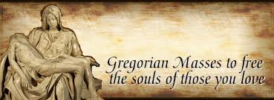
You can have Masses offered for
someone’s birthday, wedding, baptism or in memory of your deceased loved ones. Contact the office for days and times that you wish to have the Mass celebrated. What a wonderful spiritual gift!

A Gregorian Mass is for the faithfully departed.
The Holy Mass is said daily for thirty days.

Please come by the office today and offer a Gregorian Mass for your loved one!
Immaculate Conception Church
Marlow
**********************************
Collections:
Nov 12: Operating: $1,079.00
Building: $110.00

Saint Patrick Catholic Church
Walters, Oklahoma 73572
********************************
Collections:
Nov 12: Operating $1,162.06
Bldg: $270.00

DUNCAN COLLECTIONs FOR
November 11-12:
Duncan: $1,776.28
Weekly Electronic Donations: $1,200.00
Second Collection: $276.78
Scholarship Fund: $25.00
Building Fund: $100.00
St. Vincent de Paul: $25.00
RYAN: $145.00

Thank you for your generosity!!!

If you have a Pastoral Emergency please contact 580-786-2098

