Twenty-Ninth Sunday in Ordinary Time
October 22, 2017
Sep[t, 2017

Mass Intentions / Peticiones de Misa

Sat | Oct 21 | 4:00p D | (+) Joanne Rogers Miller (G)  You are cordially invited to the Deaconate Ordination Mass of our Parishioner Mark Gildon. The Mass will take place on Friday, Nov 3 at 7 p.m. in Our Lady Cathedral in Oklahoma City. We invite you to join us for 10 a.m. Mass on Sun Nov 5 during which we will receive Mark to our Parish as a Deacon. Due to this celebration we will cancel 8 a.m. Marlow, 12:00 p.m. Walters and 2 p.m. Spanish Masses. There will only be a 10 a.m. Mass followed by a catered lunch in the R.E. Building. The lunch is free of charge; however, you must sign up to attend after weekend Masses. Do not call the office to put your name on the list. The last day for sign up is Oct 29. Let us all show our support for Mark as he begins his Ministry within our Parish Community.
 |  | 6:00p R | (+) Irene
Sun | Oct 22 | 8:00a M | (+) Mary Ann Schoen  by Otto Schoen | Christmas Bazaar  Our Christmas Bazaar  will be held  November 18, 19 and 20.  We hope everyone is making  beautiful items for sale.  There will also be a raffle for  three Visa cards:  $1,000, $500 and $250!  The raffle tickets are for sale now!  They are $5.00 each or five for $20.00! Please buy tickets and  also check them out to sell.  Let’s come together and  work hard to make this a  successful event!
 |  | 10:00a D | (+) Alice Barnes  by Carolyn Trostle
 |  | 12:00p W | (+) Joanne Rogers Miller (G)
 |  | 2:00p D | (+) Pablo Tovar  by Carmen Hunsucker
Mon | Oct 23 | 12:10p D | NO MASS – Clergy Retreat
Tues | Oct 24 | 12:10p D | NO MASS – Clergy Retreat
Wed | Oct 25 | 12:10p D | NO MASS – Clergy Retreat
Thur | Oct 26 | 12:10p D | NO MASS – Clergy Retreat
Fri | Oct 27 | 12:10p D | NO MASS – Clergy Retreat
Sat | Oct 28 | 4:00p D | Mark Hebert on his birthday
 |  | 6:00p R | (+) Dorothy & Charles Scott
Sun | Oct 29 | 8:00a M | Int of Howard Doerr  by Janet Deeg
 |  | 10:00a D | (+) George Cocoma  by Nancy and Joe Litsch
 |  | 12:00p W
 |  | 2:00p D | (+) Dorothy & Charles Scott
Christmas Bazaar 2017

Our Christmas Bazaar will be held
November 17, 18 and 19.

RAFFLE TICKETS:
1 Tkt for $20
6 Tkts for $100


*1st - $3,000
*2nd - $1,000
*3rd ; $500
*4th - $250
*5th - $250
Drawing Sunday, Nov 19 at 5 p.m.
Need not be present to win.

Credit/Debit Cards accepted!!!

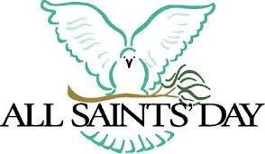

ATTENTION:

Wednesday,
November 1, 2017
is All Saints Day and a
Holy Day of Obligation

There will be
two Masses in Duncan:

12:10 p.m. and 7:00 p.m.

Third Annual Christmas Bazaar
November 20, 21 and 22
Attention: There will be a work day on Saturday, October 10 at 10 a.m. in Gillespie Hall! We need your ideas! It will take all of us participating to make our Bazaar a success!!!

Eggrolls by Agnes, order now.
She will only make 20 dozen.
They are $40 per dozen.
Pick up will be Friday, October 16.
Place order and pay at the office.

Order Tamales by Carmen
at $25.00 per dozen.
Order and pay at the office.
Pick up will be
Saturday, Nov 14.

The profit will equally be divided between three Parishes: Walters, Duncan and Marlow for the purpose of the building fund. We need your time, talent and treasure to make this event successful.

Abuse of Minors Response Hotline 405-720-987 or DHS at 1-800-522-3511.
Telefóno Pastoral para Reportar Abuso de Menores 405-720-9878 o el Departamento de Servicios Humanos 1-800-522-3511.

Mark your calendar for Catholic Foundation’s presentation on wills and trusts. This will be held on Monday, October 24 at 7 p.m. at Assumption Catholic Church Gillespie Hall. Come and learn how to take care of those you love.
You can have a Mass said for someone's intentions at their birthday, wedding, baptism, or in memory of your deceased loved ones. Contact he office for days and times that you wish to have the Mass celebrated. What a precious gift!


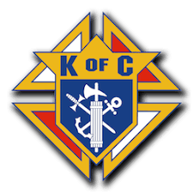

The Knights of Columbus will be holding an Open House Membership Drive after Mass in Marlow, Sunday, October 22 and in Duncan Gillespie Hall on Sunday, October 29 after all Masses.

Religious Education (RE) Families:
Please note the following dates:
Sunday, October 15 | Class
Wed, October 18 | No Class- Fall Break
Sunday, October 22 | No Class-Fall Break
Wed, October 25 | Class
Sunday, October 29 | -Class  -Confirmation 1 and 2 Parent Meeting at 11:15am in English and 12:00 in Spanish
Class times are as follows:
Grades 1-6 meet on Wednesday
from 6:00pm-7:30pm
Grades 7-12 meet on Sunday
from 11:00pm-12:30pm
Please drop the children off on time
and pick up promptly!

For any questions or concerns regarding Religious Education you may reach me at maria.martinez@yahoo.com or you may call the church office and leave a message.
Maria Martinez, RE Director

Catholic young adults of OKC
Open to all young adults (ages 18-39, married or single) in the archdiocese. Visit our Facebook page (Catholic Young Adults of OKC) for events and information or e-mail info@catholicyoungadultsokc.com.

Immaculate Conception Church
Marlow
**********************************
Collections:
Oct 15: Operating: $433.00
Building: $150.00

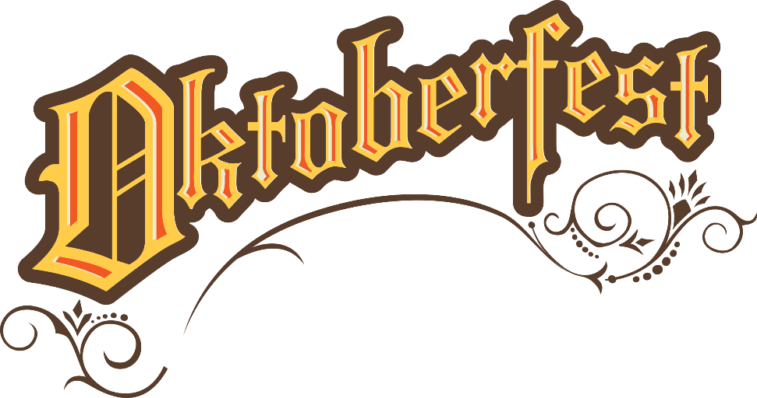
Saturday, October 28, 2017

Immaculate Conception Catholic Church Marlow
Starting at 6:00 PM
Featuring: German beer, garden music,
50-50 raffle drawing,
Silent Auction,
Free Bingo with Prizes!

Church will provide brats, rolls,
strudels, tea, lemonade and appetizers

Please bring German dishes from home
along with desserts

Let us know if you are coming,
sign up at Marlow church or call
Bill Havron @ 580-512-6867 or
580-641-1867 by Oct 25th.
If no answer, leave a message!

DUNCAN COLLECTIONs FOR
Oct 14-15:
Duncan: $1,135.00
Weekly Electronic Donations: $1,200.00
Second Collection: $204.00
Building: $281.00
Food Bank: $19.00
Ryan: $190.00
Thank you for your generosity!!!

