Twenty-Sixth Sunday in Ordinary Time
October 1, 2017
Sep[t, 2017

Mass Intentions / Peticiones de Misa

Christmas Bazaar 2017

Our Christmas Bazaar will be held
November 17, 18 and 19.

RAFFLE TICKETS:
1 Tkt for $20
6 Tkts for $100


*1st - $3,000
*2nd - $1,000
*3rd ; $500
*4th - $250
*5th - $250
Drawing Sunday, Nov 19 at 5 p.m.
Need not be present to win.
Sat | Sep 30 | 4:00p D | (+) Joanne Rogers Miller (G)
 |  | 6:00p R | (+) Frank Bannish (G)
Sun | Oct 1 | 8:00a M | (+) Ada & Joe Duesman  By Fr. Peter | Christmas Bazaar  Our Christmas Bazaar  will be held  November 18, 19 and 20.  We hope everyone is making  beautiful items for sale.  There will also be a raffle for  three Visa cards:  $1,000, $500 and $250!  The raffle tickets are for sale now!  They are $5.00 each or five for $20.00! Please buy tickets and  also check them out to sell.  Let’s come together and  work hard to make this a  successful event!
 |  | 10:00a D | (+) Mark Ross by Michelle Ross
 |  | 12:00p W
 |  | 2:00p D | (+) Joanne Rogers Miller (G)
Mon | Oct 2 | 12:10p D | (+) Jack Geurkink  (+) Joanne Rogers Miller (G)
Tues | Oct 3 | 12:10p D | (+) Paul  (+) Joanne Rogers Miller (G)
Wed | Oct 4 | 12:10p D | (+) Joanne Rogers Miller (G)
Thur | Oct 5 | 12:10p D | (+) Joanne Rogers Miller (G)
Fri | Oct 6 | 12:10p D | (+) Joanne Rogers Miller (G)
Sat | Oct 7 | 4:00p D | (+) Joanne Rogers Miller (G)
 |  | 6:00p R | For the Parishioners
Sun | Oct 8 | 8:00a M | (+) Joanne Rogers Miller (G)
 |  | 10:00a D | Int of Howard Doerr by the  Wolfgang-Deeg Family
 |  | 12:00p W
 |  | 2:00p D
ATTENTION: Due to the cold and flu season fast approaching we will discontinue the distribution of the Precious Blood on Saturday and Sunday, October 14-15 until further notice.

You are cordially invited to the Deaconate Ordination Mass of our Parishioner Mark Gildon. The Mass will take place on Friday, Nov 3 at 7 p.m. in Our Lady Cathedral in Oklahoma City. We invite you to join us for 10 a.m. Mass on Sun Nov 5 during which we will receive Mark to our Parish as a Deacon. Due to this celebration we will cancel 8 a.m. Marlow, 12:00 p.m. Walters and 2 p.m. Spanish Masses. There will only be a 10 a.m. Mass followed by a catered reception in the R.E. Building. The reception is free of charge; however, you must sign up to attend after weekend Masses. Do not call the office to put you name on the list. The last day for sign up is Oct 29. Let us all show our support for Mark as he begins his Ministry within our Parish Community.

Duncan

We are collecting $10.00 dues after all Masses this weekend.
Just remember all ladies of the Parish are members of the Altar Society!

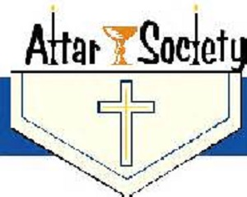

Third Annual Christmas Bazaar
November 20, 21 and 22
Attention: There will be a work day on Saturday, October 10 at 10 a.m. in Gillespie Hall! We need your ideas! It will take all of us participating to make our Bazaar a success!!!

Eggrolls by Agnes, order now.
She will only make 20 dozen.
They are $40 per dozen.
Pick up will be Friday, October 16.
Place order and pay at the office.

Order Tamales by Carmen
at $25.00 per dozen.
Order and pay at the office.
Pick up will be
Saturday, Nov 14.

The profit will equally be divided between three Parishes: Walters, Duncan and Marlow for the purpose of the building fund. We need your time, talent and treasure to make this event successful.

Abuse of Minors Response Hotline 405-720-987 or DHS at 1-800-522-3511.
Telefóno Pastoral para Reportar Abuso de Menores 405-720-9878 o el Departamento de Servicios Humanos 1-800-522-3511.

Mark your calendar for Catholic Foundation’s presentation on wills and trusts. This will be held on Monday, October 24 at 7 p.m. at Assumption Catholic Church Gillespie Hall. Come and learn how to take care of those you love.
You can have a Mass said for someone's intentions at their birthday, wedding, baptism, or in memory of your deceased loved ones. Contact he office for days and times that you wish to have the Mass celebrated. What a precious gift!


Carnival, Sunday, October 8
We invite everyone to participate in our yearly Carnival which will take place Sunday, Oct 8 from 11-4 p.m. We will have a variety of children’s activities, games, food and other attractions. The profits from this Event will go for the Feast of our Lady of Guadalupe flowers. Thank you for your support.

Todos invitados al Carnaval annual, que sera el 8 de Oct de las 11am alas 4 pm. Habra: Juegos y antojitos maxicanos lo recavdado sera par alas Flores de la Virge de Guadalupe Bienvenidos! Gracias!

Enrollment:
Welcome back to the 2017-2018 Religious Education classes!
Grades 7-12, Sundays
11:00am-12:30pm

Grades 1-6, Wednesdays
6:00pm-7:30pm for grades 1-6.

For any questions please contact me at (580) 255-0095 or email at
Maria.martinez02@yahoo.com

La Kermas Annual sera el 8 de Oct de las 11 am a las 4 pm. “Necesitamos mas puestos” lo recauda do sera par alas Flores de la Virgen de Guadalupe communicate: con Carmen Garcia. Garcia!

Assumption Catholic Church
Parish Bingo Night!
Saturday, Oct 14 at 7 p.m.
The Knights of Columbus 5168 will sponsor a Parish Bingo night with a Chilli Dinner to be served at 6:30 p.m. followed by 15 bingo games at 7 p.m. Saturday, October 14th weather permitting. The Event will be held in the Assumption Catholic Church RE Auditorium at 7th and Hickory Street. Donations for the meal will be accepted and proceeds from the event will go towards the Knights of Columbus Hurricane Relief Efforts.

Immaculate Conception Church
Marlow
**********************************
Collections:
Sep 24: Operating: $470.00
Building: $100.00

DUNCAN COLLECTIONs FOR
SEP 23-24:
Duncan: $1,860.00
Weekly Electronic Donations: $1,200.00
Second Collection: $89.00
Building Fund: $20.00
Food Bank: $100.00
Thank you for your generosity!!!

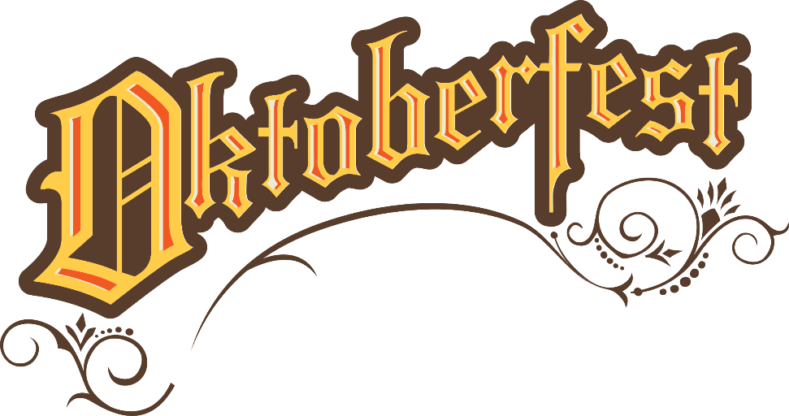
Saturday, October 28, 2017

Immaculate Conception Catholic Church Marlow
Starting at 6:00 PM
Featuring: German beer, garden music,
50-50 raffle drawing,
Silent Auction,
Free Bingo with Prizes!

Church will provide brats, rolls,
strudels, tea, lemonade and appetizers

Please bring German dishes from home
along with desserts

Let us know if you are coming,
sign up at Marlow church or call
Bill Havron @ 580-512-6867 or
580-641-1867 by Oct 25th.
If no answer, leave a message!

Today’s responsorial psalm is “The Lord is near to all who call upon him”. Catholic Charities is present to those who are in need, through case management, homeless services, counseling, immigration and refugee services. Be an answer to your neighbor’s call by donating to Catholic Charities at givetocc.org to support the annual appeal as you are able

