Twenty-Fifth Sunday in Ordinary Time
September 24, 2017
Sep[t, 2017

Christmas Bazaar 2017

Our Christmas Bazaar will be held
November 17, 18 and 19.

RAFFLE TICKETS:
1 Tkt for $20
6 Tkts for $100


*1st - $3,000
*2nd - $1,000
*3rd ; $500
*4th - $250
*5th - $250
Drawing Sunday, Nov 19 at 5 p.m.
Need not be present to win.
Mass Intentions / Peticiones de Misa

Sat | Sep 23 | 4:00p D | (+) Frank Bannish , Gregorian
 |  | 6:00p R | No Mass
Sun | Sep 24 | 8:00a M | (+) Joanne Rogers Miller (G) | Christmas Bazaar  Our Christmas Bazaar  will be held  November 18, 19 and 20.  We hope everyone is making  beautiful items for sale.  There will also be a raffle for  three Visa cards:  $1,000, $500 and $250!  The raffle tickets are for sale now!  They are $5.00 each or five for $20.00! Please buy tickets and  also check them out to sell.  Let’s come together and  work hard to make this a  successful event!
 |  | 10:00a D | (+) Robert Conway  by Joe Murphy
 |  | 12:00p W | (+) Lester Laudick  by Joe Murphey
 |  | 2:00p D | (+) Frank Bannish, Gregoria
Mon | Sep 25 | 12:10p D | (+) Frank Bannish , Gregorian  (+) Joanne Rogers Miller (G)
Tues | Sep 26 | 12:10p D | (+) Frank Bannish , Gregorian  (+) Joanne Rogers Miller (G)
Wed | Sep 27 | 12:10p D | (+) Frank Bannish , Gregorian  (+) Joanne Rogers Miller (G)
Thur | Sep 28 | 12:10p D | (+) Frank Bannish , Gregorian  (+) Joanne Rogers Miller (G)
Fri | Sep 29 | 12:10p D | (+) Frank Bannish , Gregorian  (+) Joanne Rogers Miller (G)
Sat | Sep 30 | 4:00p D | (+) Joanne Rogers Miller (G)
 |  | 6:00p R | (+) Frank Bannish (G)
Sun | Oct 1 | 8:00a M | (+) Ada & Joe Duesman  By Fr. Peter
 |  | 10:00a D
 |  | 12:00p W
 |  | 2:00p D | (+) Joanne Rogers Miller (G)
Duncan

We are collecting $10.00 dues after all Masses this weekend and next.

Just remember all ladies of the Parish are members of the Altar Society!
Movimiento de Cursillos
Archdiocese of Oklahoma City
Encuentro Region VIII 2017
“Volver a la Funte de Agua Viva”
Catholic Pastoral Center
Archdiocese of OKC
October 27-28, 2017
Celebrando 60 Anos de Cursillos Registrate Hoy!!

Registrese en cuanto antes para acegurar cama si decea aojarse en el Centro Pastoral, Para mas information:
Jose Mejia 405-613-5810
Susan-hall@ouhsc.edu
Cursillossecretary@yahoo.com

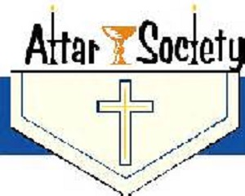

Third Annual Christmas Bazaar
November 20, 21 and 22
Attention: There will be a work day on Saturday, October 10 at 10 a.m. in Gillespie Hall! We need your ideas! It will take all of us participating to make our Bazaar a success!!!

Eggrolls by Agnes, order now.
She will only make 20 dozen.
They are $40 per dozen.
Pick up will be Friday, October 16.
Place order and pay at the office.

Order Tamales by Carmen
at $25.00 per dozen.
Order and pay at the office.
Pick up will be
Saturday, Nov 14.

The profit will equally be divided between three Parishes: Walters, Duncan and Marlow for the purpose of the building fund. We need your time, talent and treasure to make this event successful.

Abuse of Minors Response Hotline 405-720-987 or DHS at 1-800-522-3511.
Telefóno Pastoral para Reportar Abuso de Menores 405-720-9878 o el Departamento de Servicios Humanos 1-800-522-3511.

Mark your calendar for Catholic Foundation’s presentation on wills and trusts. This will be held on Monday, October 24 at 7 p.m. at Assumption Catholic Church Gillespie Hall. Come and learn how to take care of those you love.
You can have a Mass said for someone's intentions at their birthday, wedding, baptism, or in memory of your deceased loved ones. Contact he office for days and times that you wish to have the Mass celebrated. What a precious gift!


Parish Youth Soccer Challenge

Wednesday, Sept 27, 2017
Where: Assumption School Grounds
Time: 6:00 PM until 8:00 PM
All boys & girls ages 10-14 are encouraged to participate and be eligible to win new soccer balls and qualify for the Knights of Columbus State Soccer Challenge. The Knights of Columbus will also offer ‘FREE HAMBURGERS, CHIPS AND DRINK MEAL’ during the event. So grab your parents and treat them to supper and have fun kicking the soccer ball. All Parishioners are welcome to come out and enjoy the Wednesday evening event & meal. It should be lots of fun for everyone.

Enrollment:
Welcome back to the 2017-2018 Religious Education classes!
Grades 7-12, Sundays
11:00am-12:30pm

Grades 1-6, Wednesdays
6:00pm-7:30pm for grades 1-6.

For any questions please contact me at (580) 255-0095 or email at
Maria.martinez02@yahoo.com

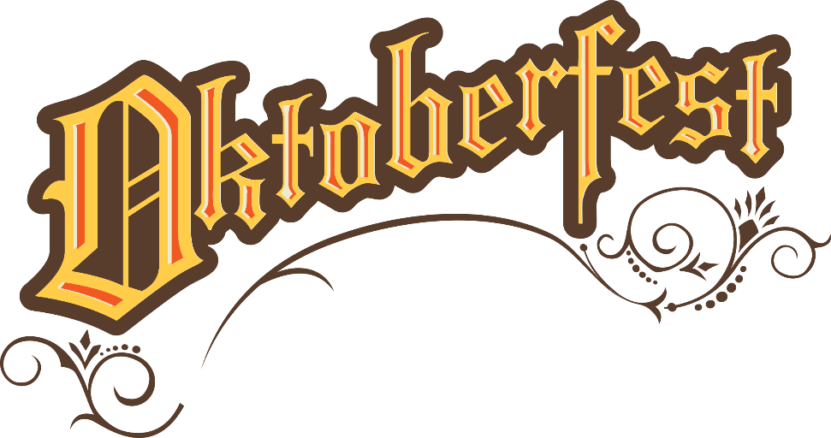
Saturday, October 28, 2017

Immaculate Conception Catholic Church Marlow
Starting at 6:00 PM
Featuring: German beer, garden music,
50-50 raffle drawing,
Silent Auction,
Free Bingo with Prizes!

Church will provide brats, rolls,
strudels, tea, lemonade and appetizers

Please bring German dishes from home
along with desserts

Let us know if you are coming, sign up at Marlow church or call
Bill Havron @ 580-512-6867 or
580-641-1867 by Oct 25th.
If no answer, leave a message!

DUNCAN COLLECTIONs FOR
SEP 16-17:
Duncan: $1,775.00
Weekly Electronic Donations: $1,200.00
Food Bank: $104.00
St. Vincent de Paul: $55.00
Building Fund: $30.00
Scholarship: $20.00
Catholic Charities: $200.00
Thank you for your generosity!!!

Saint Patrick Catholic Church
Walters, Oklahoma 73572
********************************
Collections:
Sep 17: Operating $1,326.00
Bldg: $20.00

Immaculate Conception Church
Marlow
**********************************
Collections:
Sep 17: Operating: $437.00
Building: $140.00

Today’s responsorial psalm is “The Lord is near to all who call upon him”. Catholic Charities is present to those who are in need, through case management, homeless services, counseling, immigration and refugee services. Be an answer to your neighbor’s call by donating to Catholic Charities at givetocc.org to support the annual appeal as you are able

