Twenty-Fourth Sunday in Ordinary Time
September 17, 2017
Sep[t, 2017

Christmas Bazaar 2017

Our Christmas Bazaar will be held
November 17, 18 and 19.

RAFFLE TICKETS:
1 Tkt for $20
6 Tkts for $100


*1st - $3,000
*2nd - $1,000
*3rd ; $500
*4th - $250
*5th - $250
Drawing Sunday, Nov 19 at 5 p.m.
Need not be present to win.
Mass Intentions / Peticiones de Misa

Sat | Sep 16 | 4:00p D | (+) Jim Weaver by Joe Murphy
 |  | 6:00p R | (+) Frank Bannish , Gregorian
Sun | Sep 17 | 8:00a M | (+) Frank Bannish , Gregorian | Christmas Bazaar  Our Christmas Bazaar  will be held  November 18, 19 and 20.  We hope everyone is making  beautiful items for sale.  There will also be a raffle for  three Visa cards:  $1,000, $500 and $250!  The raffle tickets are for sale now!  They are $5.00 each or five for $20.00! Please buy tickets and  also check them out to sell.  Let’s come together and  work hard to make this a  successful event!
 |  | 10:00a D | Happy Birthday Ann Boice
 |  | 12:00p W | For the Parishioners
 |  | 2:00p D | (+) Justino Salazar by Carolina
Mon | Sep 18 | 12:10p D | (+) Frank Bannish , Gregorian
Tues | Sep 19 | 12:10p D | (+) Frank Bannish , Gregorian
Wed | Sep 20 | 12:10p D | (+) Frank Bannish , Gregorian
Thur | Sep 21 | 12:10p D | (+) Frank Bannish , Gregorian
Fri | Sep 22 | 12:10p D | (+) Frank Bannish , Gregorian
Sat | Sep 23 | 4:00p D | (+) Lester Laudick  by Joe Murphey
 |  | 6:00p R | (+) Frank Bannish, Gregorian
Sun | Sep 24 | 8:00a M | (+) Joanne Rogers Miller
 |  | 10:00a D | (+) Robert Conway  by Joe Murphy
 |  | 12:00p W
 |  | 2:00p D | (+) Frank Bannish, Gregorian
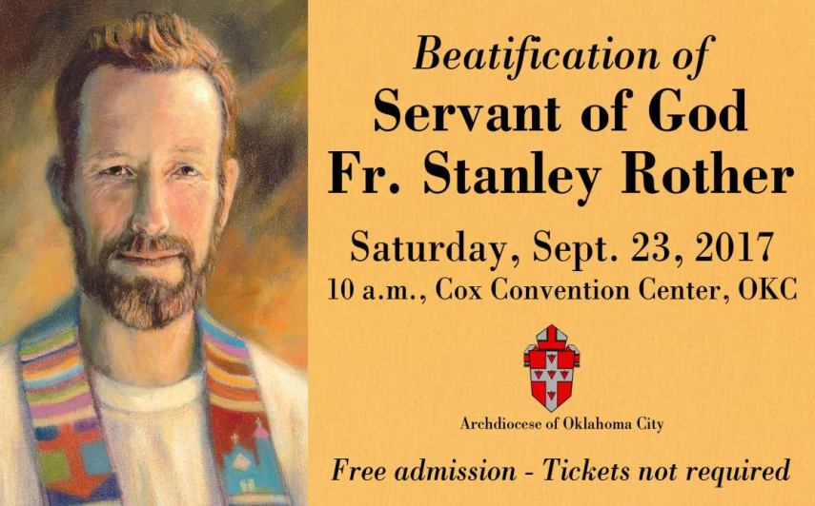

Movimiento de Cursillos
Archdiocese of Oklahoma City
Encuentro Region VIII 2017
“Volver a la Funte de Agua Viva”
Catholic Pastoral Center
Archdiocese of OKC
October 27-28, 2017
Celebrando 60 Anos de Cursillos Registrate Hoy!!

Registrese en cuanto antes para acegurar cama si decea aojarse en el Centro Pastoral, Para mas information:
Jose Mejia 405-613-5810
Susan-hall@ouhsc.edu
Cursillossecretary@yahoo.com

Beginning RCIA Classes –
2017-2018
RCIA (The Rite of Christian Initiation for Adults) is a vibrant informative program for adults who are interested in joining the Catholic Church. If you are interested or know of someone who is interested in learning about our Catholic Faith, RCIA Inquiry one hour sessions will be starting SUNDAY, AUGUST 27, 2017 after the 10AM Mass in Duncan. An open invitation is also extended to current Catholics that want to know and learn more about our faith as well as Catholic Adults interested in becoming Catechist (Teachers) or Sponsors. For additional information on these RCIA Inquiry sessions, please contact Mike or Lucy Radtke at 606-0283 or 656-7582 or email mikelucy@live.com.

Third Annual Christmas Bazaar
November 20, 21 and 22
Attention: There will be a work day on Saturday, October 10 at 10 a.m. in Gillespie Hall! We need your ideas! It will take all of us participating to make our Bazaar a success!!!

Eggrolls by Agnes, order now.
She will only make 20 dozen.
They are $40 per dozen.
Pick up will be Friday, October 16.
Place order and pay at the office.

Order Tamales by Carmen
at $25.00 per dozen.
Order and pay at the office.
Pick up will be
Saturday, Nov 14.

The profit will equally be divided between three Parishes: Walters, Duncan and Marlow for the purpose of the building fund. We need your time, talent and treasure to make this event successful.

Abuse of Minors Response Hotline 405-720-987 or DHS at 1-800-522-3511.
Telefóno Pastoral para Reportar Abuso de Menores 405-720-9878 o el Departamento de Servicios Humanos 1-800-522-3511.

Mark your calendar for Catholic Foundation’s presentation on wills and trusts. This will be held on Monday, October 24 at 7 p.m. at Assumption Catholic Church Gillespie Hall. Come and learn how to take care of those you love.
You can have a Mass said for someone's intentions at their birthday, wedding, baptism, or in memory of your deceased loved ones. Contact he office for days and times that you wish to have the Mass celebrated. What a precious gift!


Parish Youth Soccer Challenge

Wednesday, Sept 27, 2017
Where: Assumption School Grounds
Time: 6:00 PM until 8:00 PM
All boys & girls ages 10-14 are encouraged to participate and be eligible to win new soccer balls and qualify for the Knights of Columbus State Soccer Challenge. The Knights of Columbus will also offer ‘FREE HAMBURGERS, CHIPS AND DRINK MEAL’ during the event. So grab your parents and treat them to supper and have fun kicking the soccer ball. All Parishioners are welcome to come out and enjoy the Wednesday evening event & meal. It should be lots of fun for everyone.

Enrollment:
Welcome back to the 2017-2018 Religious Education classes. Enrollment will take place after each mass starting the weekend of August 19-20. You may enroll during the week at the office. A donation of $30.00 per family will be collected to help with supplies and materials teachers might need in the classroom. Classes will begin on Sunday, September 17, 2017 at 11:00am (after mass is over)- 12:30pm for grades 7-12 and Wednesday, September 20, 2017 from 6:00pm-7:30pm for grades 1-6.

Catechist there will be a meeting on September 30th at 6:30 in the Religious Education (RE) building. Dinner will be provided!

For any questions please contact me at (580) 255-0590 or email at
Maria.martinez02@yahoo.com

Appeal Weekend – Today’s responsorial psalm, the Lord is kind and merciful, slow to anger, and rich in compassion. Help share kindness and compassion to those in need by supporting Catholic Charities. Donate to Catholic Charities at givetocc.org to support the annual appeal as you are able.
DUNCAN COLLECTIONs FOR
SEP 9-10:
Duncan: $2,199.75
Weekly Electronic Donations: $1,200.00
Second Collection: $52.00
St. Vincent de Paul: $130.00
Scholarship: $20.00
RYAN: $111.00
Thank you for your generosity!!!

Saint Patrick Catholic Church
Walters, Oklahoma 73572
********************************
Collections:
Aug 27: Operating $240.00 Bldg: $145.00
Sep 3: Operating $621.20 Bldg: $330.00
Sep 10: Operating $900.77 Bldg: $270.00

Anniversary Mass
Archbishop Coakley invites married couples who are celebrating milestone anniversaries (25, 40, 50+) in the calendar year 2017 to attend a special Anniversary Mass at 3 p.m. Oct. 15 at The Cathedral of Our Lady of Perpetual Help, 3214 N. Lake Ave., OKC. A reception will follow. Contact the Office of Family Life at (405) 721-8944 if attending. The archbishop will impart his blessing and the local Catholic community will rejoice in the example and commitment to your Sacrament of Marriage.

