Twenty-Second Sunday in Ordinary Time
September 3, 2017
Sep[t, 2017

Mass Intentions / Peticiones de Misa

Sat | Sep 2 | 4:00p D | (+) Frank Bannish , Gregorian  Christmas Bazaar 2017  Our Christmas Bazaar will be held  November 17, 18 and 19.  RAFFLE TICKETS:  1 Tkt for $20  6 Tkts for $100    *1st - $3,000  *2nd - $1,000  *3rd ; $500  *4th - $250  *5th - $250  Drawing Sunday, Nov 19 at 5 p.m.  Need not be present to win.
 |  | 6:00p R | (+) Bill Sheets by Joe Murphy
Sun | Sep 3 | 8:00a M |  | Christmas Bazaar  Our Christmas Bazaar  will be held  November 18, 19 and 20.  We hope everyone is making  beautiful items for sale.  There will also be a raffle for  three Visa cards:  $1,000, $500 and $250!  The raffle tickets are for sale now!  They are $5.00 each or five for $20.00! Please buy tickets and  also check them out to sell.  Let’s come together and  work hard to make this a  successful event!
 |  | 10:00a D | (+) Gary Barnes by Joe Murphy
 |  | 12:00p W
 |  | 2:00p D | (+) Frank Bannish , Gregorian
Mon | Sep 4 | 12:10p D | (+) Frank Bannish , Gregorian
Tues | Sep 5 | 12:10p D | (+) Frank Bannish , Gregorian
Wed | Sep 6 | 12:10p D | (+) Frank Bannish , Gregorian
Thur | Sep 7 | 12:10p D | (+) Frank Bannish , Gregorian
Fri | Sep 8 | 12:10p D | (+) Frank Bannish , Gregorian
Sat | Sep 9 | 4:00p D | (+) Frank Bannish , Gregorian
 |  | 6:00p R | Int of Howard Doerr by the Wolfgang-Deeg Family
Sun | Sep 10 | 8:00a M
 |  | 10:00a D | Living & Deceased Members  of the Altar Society
 |  | 12:00p W | (+) Frank Bannish , Gregorian
 |  | 2:00p D | For the Parishioners

Please Notice: The office will be closed on Monday, September 4 because of the Labor Day Holiday.

ATTENTION
ALL LADIES OF THE
DUNCAN PARISH
Duncan Altar Society Meeting
Wednesday,
September 13, 2017
After 12:10 Mass.
Bring a dish for our
pot luck lunch.
All ladies of the Parish
are members of the
Altar Society!

Beginning RCIA Classes –
2017-2018
RCIA (The Rite of Christian Initiation for Adults) is a vibrant informative program for adults who are interested in joining the Catholic Church. If you are interested or know of someone who is interested in learning about our Catholic Faith, RCIA Inquiry one hour sessions will be starting SUNDAY, AUGUST 27, 2017 after the 10AM Mass in Duncan. An open invitation is also extended to current Catholics that want to know and learn more about our faith as well as Catholic Adults interested in becoming Catechist (Teachers) or Sponsors. For additional information on these RCIA Inquiry sessions, please contact Mike or Lucy Radtke at 606-0283 or 656-7582 or email mikelucy@live.com.

Third Annual Christmas Bazaar
November 20, 21 and 22
Attention: There will be a work day on Saturday, October 10 at 10 a.m. in Gillespie Hall! We need your ideas! It will take all of us participating to make our Bazaar a success!!!

Eggrolls by Agnes, order now.
She will only make 20 dozen.
They are $40 per dozen.
Pick up will be Friday, October 16.
Place order and pay at the office.

Order Tamales by Carmen
at $25.00 per dozen.
Order and pay at the office.
Pick up will be
Saturday, Nov 14.

The profit will equally be divided between three Parishes: Walters, Duncan and Marlow for the purpose of the building fund. We need your time, talent and treasure to make this event successful.

Abuse of Minors Response Hotline 405-720-987 or DHS at 1-800-522-3511.
Telefóno Pastoral para Reportar Abuso de Menores 405-720-9878 o el Departamento de Servicios Humanos 1-800-522-3511.

Mark your calendar for Catholic Foundation’s presentation on wills and trusts. This will be held on Monday, October 24 at 7 p.m. at Assumption Catholic Church Gillespie Hall. Come and learn how to take care of those you love.
You can have a Mass said for someone's intentions at their birthday, wedding, baptism, or in memory of your deceased loved ones. Contact he office for days and times that you wish to have the Mass celebrated. What a precious gift!

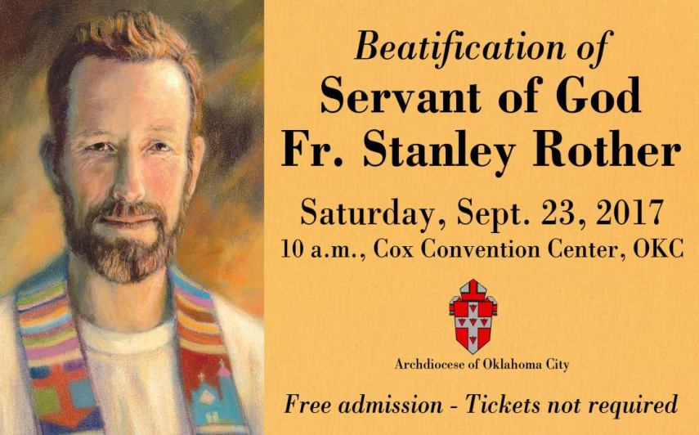


Enrollment:
Welcome back to the 2017-2018 Religious Education classes. Enrollment will take place after each mass starting the weekend of August 19-20. You may enroll during the week at the office. A donation of $30.00 per family will be collected to help with supplies and materials teachers might need in the classroom. Classes will begin on Sunday, September 17, 2017 at 11:00am (after mass is over)- 12:30pm for grades 7-12 and Wednesday, September 20, 2017 from 6:00pm-7:30pm for grades 1-6.

Catechist there will be a meeting on September 30th at 6:30 in the Religious Education (RE) building. Dinner will be provided!

For any questions please contact me at (580) 255-0590 or email at
Maria.martinez02@yahoo.com

Charismatic Catholic prayer Meetings
Charismatic Catholic prayer meetings are held at 7 p.m. every Thursday at the Catholic Pastoral Center. Bring your Bible. Contact Toni Calvey at (405) 630-0539, toni-calvey1900@gmail.com or visit www.spiritOKC.org.

Catholic Women:
Living the Joy of the Gospel
Catholic women are invited to the National Council of Catholic Women 2017 Convention Sept. 7-9 at the Hilton Anatole in Dallas. Celebrate Living the Joy of the Gospel through liturgies, devotions and guest speakers. Contact Becky VanPool, (405) 834-3782 or visit www.nccw.org/2017AnnualConvention.

Anniversary Mass
Archbishop Coakley invites married couples who are celebrating milestone anniversaries (25, 40, 50+) in the calendar year 2017 to attend a special Anniversary Mass at 3 p.m. Oct. 15 at The Cathedral of Our Lady of Perpetual Help, 3214 N. Lake Ave., OKC. A reception will follow. Contact the Office of Family Life at (405) 721-8944 if attending. The archbishop will impart his blessing and the local Catholic community will rejoice in the example and commitment to your Sacrament of Marriage.

Catholic Young Adults of OKC
Open to all young adults (ages 18-39, married or single) in the archdiocese. Visit our Facebook page (Catholic Young Adults of OKC) for events and information or e-mail info@catholicyoungadultsokc.com.

In today’s gospel, Jesus calls us to take up our cross and follow him. Helping others with their cross or burdens in life is something that Catholic Charities does by helping others daily in your name. Donate to Catholic charities at givetocc.org to support the annual appeal as you are able.

