Thirteenth Sunday in Ordinary Time
June 26, 2016

ATTENTION:
The office will be closed Monday, July 4th in observance of
Independence Day!
Mass Intentions / Peticiones de Misa

Sat | June 25 | 4:00p D | God’s Blessings for Robbin on her Birthday
 |  | 6:00p R | (+) Bill Mullen
Sun | June 26 | 8:00a M
 |  | 10:00a D | (+) Bill Mullen
 |  | 12:00p W |  | We're accepting donations for Guadelupe garage sale: furniture, clothing, toys, dishes, etc... To pick up items please call:  Noé Sanchez 475-4892.  Estamos recibiendo donaciones para el garage annual tras tes, nopa, juguetes y muebles Esperamos tu cooperacin communicate con Maria Jones, Carmen Garcia o Noe Sanchez. Gracias
 |  | 2:00p D
Mon | June 27 | 12:10p D | (+) Bill Mullen
Tues | June 28 | 12:10p D | (+) Bill Mullen
Wed | June 29 | 12:10p D | (+) Bill Mullen
Thur | June 30 | 12:10p D | (+) Bill Mullen
Fri | June 31 | 12:10p D | (+) Bill Mullen
Sat | July 1 | 4:00p D | (+) Bill Mullen
 |  | 6:00p R
Sun | July 2 | 8:00a M
 |  | 10:00a D | (+)Bill Mullen
 |  | 12:00p W
 |  | 2:00p D | For the Parishioners
The Parish Feast of the
Assumption of the Blessed Virgin Mary
is
Monday, August 15, 2016.
We will celebrate Mass at 6 p.m.
with a Pot Lunch Dinner to follow.

The Church will provide the
plates, drinks and also the meat.

So that we may have an assortment of food,
we ask that you bring a dish following this list:

Last Names beginning with:
A – I Salad or Vegetable
J – R Meat Casserole
S – Z Dessert/Fruit

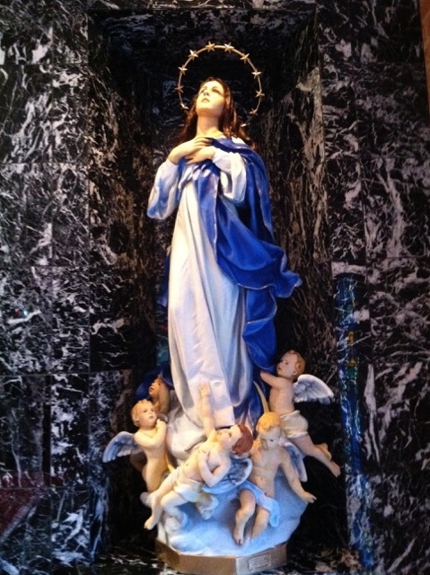

Third Annual Christmas Bazaar
November 20, 21 and 22
Attention: There will be a work day on Saturday, October 10 at 10 a.m. in Gillespie Hall! We need your ideas! It will take all of us participating to make our Bazaar a success!!!

Eggrolls by Agnes, order now.
She will only make 20 dozen.
They are $40 per dozen.
Pick up will be Friday, October 16.
Place order and pay at the office.

Order Tamales by Carmen
at $25.00 per dozen.
Order and pay at the office.
Pick up will be
Saturday, Nov 14.

The profit will equally be divided between three Parishes: Walters, Duncan and Marlow for the purpose of the building fund. We need your time, talent and treasure to make this event successful.

You can have a Mass said for someone's intentions at their birthday, wedding, baptism, or in memory of your deceased loved ones. Contact he office for days and times that you wish to have the Mass celebrated. What a precious gift!

Abuse of Minors Response Hotline 405-720-987 or DHS at 1-800-522-3511.
Telefóno Pastoral para Reportar Abuso de Menores 405-720-9878 o el Departamento de Servicios Humanos 1-800-522-3511.


Summer Parish Church Dinner & Bingo Night – Friday, July 15.

Immaculate Conception Church in Marlow will be hosting a Parish BBQ Dinner (donations will be accepted) on Friday, July 15 starting at 6 pm. To insure we have enough food we must have a head count. Please sign up by contacting Bill Havron (512-6867) or Tracey Forsythe (641-1988). Deadline for sign up is Monday July 11. Following Dinner we will hold a Free Fun Bingo event with 50/50 chances available.

We have daily adoration and
pray the
Chaplet of Divine Mercy
and the Rosary
Monday through
Friday at
11:30 a.m.
before the 12:10 Mass.
Everyone is invited
to participate and
spend time with Jesus!



Attention: Starting this weekend we will have a Second Collection to assist with our Parish Feast of Assumption Celebration on Mon, Aug 15 for flowers and pot luck dinner supplies.

Fortnight for Freedom
Celebrate Fortnight for Freedom with the archdiocese. Beginning June 21, receive daily e-mails with prayers and religious liberty news. Go online to www.flocknote.com/archokc and subscribe to the Fortnight for Freedom 2016 group.

Catholic young adults of OKC
Open to all young adults (ages 18-39, married or single) in the archdiocese. Visit our Facebook page (Catholic Young Adults of OKC) for events and information or e-mail info@catholicyoungadultsokc.com.

Did you Know: You can always donate via automatic withdrawal directly to our church's account. It is easy, simple and at the end of the fiscal year you will receive a tax letter acknowledging your donations. For more information stop by the office after each Mass.
Thank you for your support.

DUNCAN COLLECTIONs FOR June 18-19:
Duncan: $1,736.00
Weekly Electronic Donations: $1,100.00
Assumption Feast Day CelebrationL $311.59
Ryan: $112.00
Thank you for your generosity!!!

RCYC- Regional Catholic Youth Conference
The pilgrimage to the Regional Catholic Youth Conference, Nov. 18-20, will be in Beaumont, Texas. Cost is $325 per person. Fee includes bus, transportation, hotel, registration and T-shirt. Registration materials available in May.

