First Sunday of Advent
November 30, 2014

Mass Intentions / Peticiones de Misa

Sat | Nov 29 | 4:00p D | (+)Andrew Rodiger  Parish Advent Mission:  "Christ is Born"  Presented by Fr. Joseph Arledge,  December 6-10, 2014  The Mission will end Wednesday,  December 10 at 7 p.m. with  Advent Penance Service.
 |  | 6:00p R | (+)Buddy Gentry by His Sister  Theresa Blanchard
Sun | Nov 30 | 8:00a M | (+)Beverly Hoegger
 |  | 10:00a D | (+)Andrew Rodiger
 |  | 12:00p W
 |  | 2:00p D
Mon | Dec 1 | 12:10p D | (+)Andrew Rodiger  Second Annual Christmas Bazaar  December 5, 6 & 7, 2014 in Gillespie Hall  Friday, December 5, 4-8 p.m.  Saturday, December 6, 10 a.m.-7 p.m.  St. Nicholas Party for Children, 5-7 p.m.,  in R.E. Bldg  Sunday, December 7, 11 a.m. - 5 p.m.  Order Tamales by Carmen  at $25.00 per dozen.  Order and pay at the office  if you're interested!  Buy Raffle tickets now:  1. Beautiful Christmas centerpiece. Tickets are $1.00 each or six tickets for $5.00.  2. $500 Southwest Airlines Gift Card. Tickets are $5.00 each or five tickets for $20.00 or 5 tickets for $20.00!  Will be raffled off on Sunday, December 7 at Bazaar!  Proceeds will be distributed: 50% to the Building Fund, 25% to St. Vincent de Paul and 25% to our Food Bank. Everyone can contribute!
Tues | Dec 2 | 12:10p D | (+)Andrew Rodiger
Wed | Dec 3 | 12:10p D | (+)Andrew Rodiger
Thur | Dec 4 | 12:10p D | (+)Andrew Rodiger and  Living & Deceased Members of the Altar Society
Fri | Dec 5 | 12:10p D | (+)Andrew Rodiger
Sat | Dec 6 | 4:00p D | (+)Andrew Rodiger
 |  | 6:00p D | For the Good Health of Krystyna
Sun | Dec 7 | 8:00a M | (+)Kelly Hoegger
 |  | 10:00a D | (+)Pedro Martinez by  Alicia Martinez
 |  | 12:00p W | (+)Andrew Rodiger
 |  | 2:00p D | For the Parishioners
Christmas Mass Schedule

Wednesday, December 24
6 p.m. Duncan Children's Mass
6 p.m. Walters
Midnight Mass in Duncan

Thursday, December 25
9 a.m. Marlow
11 a.m. Duncan
11 a.m. Ryan

Upcoming Events:
Mon., Dec 8: Immaculate Conception Feast Day Mass, 12:10 pm in Duncan and 7 p.m. in Marlow.
Sat-Wed, Dec 6-10: Parish Advent Mission
Wed, Dec 10: 7 p.m. Penance Advent Service
Wed., Dec 24: 6 p.m. Children's Mass

Christmas Decorating,
Monday, December 22
at 4 p.m.

Everyone is invited to come help
decorate our church for Christmas.
We will meet at 4 p.m.
The more people we have
the sooner we can get done!!!


Thank you very much to the Knights of Columbus and all the volunteers for the Thanksgiving dinner. Thank you for your time, talent and treasurer!

You can have a Mass said for someone's intentions at their birthday, wedding, baptism, or in memory of your deceased loved ones. Contact he office for days and times that you wish to have the Mass celebrated. What a precious gift!

Abuse of Minors Pastoral Response Hotline 405-720-987 or DHS at 1-800-522-3511. Línea Telefónica Pastoral para Reportar Abuso de Menores 405-720-9878 o el Departamento de Servicios Humanos al 1-800-522-3511.

Our lady of Guadalupe celebration

Everyone is invited to the annual celebration
of the Virgin of Guadalupe.

Thursday, December 11
10:00pm ---------------------- Procession
11:00pm ---------------------- Matachines
(Traditional dancers)
Two Talks
Mañanitas
(Songs to Mary)
12 midnight ----------------- Mass
After Mass ------------------- Light Breakfast

Friday, December 12
4:30pm ------------------------ Rosary
5:00pm ------------------------ Apparition
6:00pm ------------------------ Mass
After Mass -------------------- Dinner
After Dinner ------------------ Matachines
Folkloric Dances

Church Donation Envelopes
Next year you will no longer receive donation envelopes in the mail. The entire year's envelopes will be available for you to pick up at the entrance of the Assumption Church or during the week in the Parish office. The envelopes should arrive shortly and we will let you know when you can pick them up!

Please Note: You can always donate via automatic withdrawal directly to our church's account. It is easy, simple and at the end of the fiscal year you will receive a tax letter acknowledging your donations. For more information stop by the office after each Mass.

Thank you for your support.
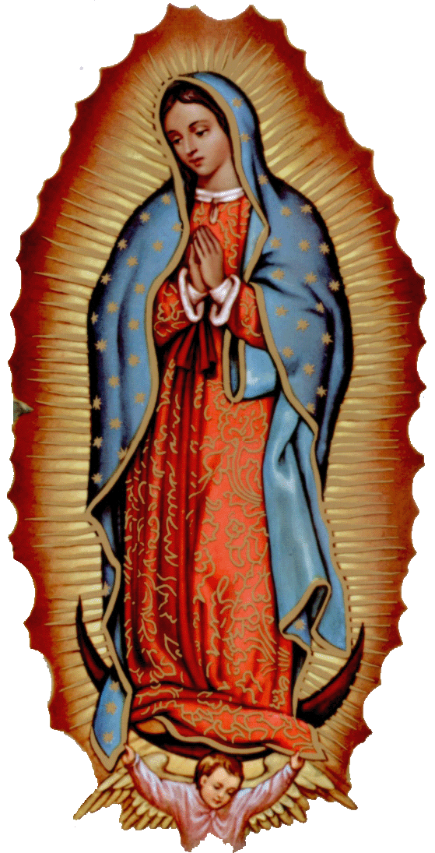



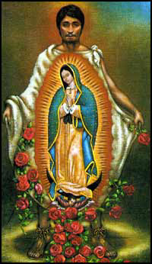
la fiesta de
La VIRGEN DE GUADALUPE

Todos están invitados a la celebración anual
de la Virgen de Guadalupe.

el jueves, 11 de diciembre
10:00pm ---------------------- La Procesión
11:00pm ---------------------- Los Matachines
Dos Temas
Las Mañanitas
12 medianoche -------------- La Misa
Después de Misa ------------ El Desayuno

el viernes, 12 de diciembre
4:30pm ---------------------- El Rosario
5:00pm ---------------------- La Aparición
6:00pm ---------------------- La Misa
Después de Misa ----------- La Cena
Después de Cena ----------- Matachines
Bailables


Please remember your Parish in your will.
DUNCAN COLLECTIONs FOR nov 22-23:
Duncan: $2,213.76
Weekly Electronic Donations: $1,225.00
Building: $5,595.00
Food Bank: $275.00
Ryan: $108.00
Thank you for your generosity!!!

Saint Patrick Catholic Church
THIRD AND OHIO POST OFFICE BOX 151
Walters, Oklahoma 73572
**************************************
Collections:
Nov 23: Operating--$330.00/Building--$125.00

CHRISTMAS FLOWER DONATIONS
There are Envelopes in the pews for donations for our Christmas Flowers and Decorations.
Thank you for your generosity.

donaciones para flores de navidad
Hay Sobres en las bancas para donaciones para las Flores y Decoraciones de Navidad.
Gracias por su generosidad.

Baptismal Classes in English:
Sunday, December 14 after 8 a.m. Mass ,Immaculate Conception, Marlow presented by Deacon Jimmy Conway

!!!Religious Education News!!!
1st-7th Grades, Wednesdays, 6:00-7:15 p.m.
8th-12th Grades, Sundays,11:15 a.m. - 12:30 p.m.
Dates to Remember:
Dec 21-Jan 4: Christmas Holiday, No R.E. Classes

