The Commemoration of All the Faithful Departed
(All Souls' Day), November 2, 2014

Parish Advent Mission:
"Christ is Born"
Presented by Fr. Joseph Arledge,
December 6-10, 2014
The Mission will end Wednesday,
December 10 at 7 p.m. with
Advent Penance Service.
Mass Intentions / Peticiones de Misa

Sat | Nov 1 | 12:10p D | For the Parishioners
 |  | 4:00p D | For the Living & Deceased Member of the KofC
 |  | 6:00p R | (+)Andrew Rodiger
Sun | Nov 2 | 8:00a M | (+)Rita Forsythe
 |  | 10:00a D | (+)Departed Maier Family Members by Aldene Maier
 |  | 12:00p W | (+)Clarence L. Neal  Second Annual Christmas Bazaar  December 5, 6 & 7, 2014 in Gillespie Hall  Friday, December 5, 4-8 p.m.  Saturday, December 6, 10 a.m.-7 p.m.  St. Nicholas Party for Children, 6-8 p.m.,  in R.E. Bldg  Sunday, December 7, 11 a.m. - 5 p.m.  Order Tamales by Carmen  at $25.00 per dozen.  Order and pay at the office  if you're interested!  Buy Raffle tickets now:  1. Beautiful Christmas centerpiece. Tickets are $1.00 each or six tickets for $5.00.  2. $500 Southwest Airlines Gift Card. Tickets are $5.00 each or five tickets for $20.00 or 5 tickets for $20.00!  Will be raffled off on Sunday, December 7 at Bazaar!  Proceeds will be distributed: 50% to the Building Fund, 25% to St. Vincent de Paul and 25% to our Food Bank. Everyone can contribute!
 |  | 2:00p D | (+)Crecencio & Paula Medrano Sr. by Alicia Martinez
Mon | Nov 3 | 12:10p D | Special Intentions of the Maier Family by Aldine
Tues | Nov 4 | 12:10p D | For God's Blessings for Matthew Neal on his Birthday
Wed | Nov 5 | 12:10p D | For God's Blessings for Luke Fitts on his Birthday
Thur | Nov 6 | 12:10p D | For the Living & Deceased Members of the Altar Society
Fri | Nov 7 | 12:10p D | (+)Andrew Rodiger
Sat | Nov 8 | 4:00p D | (+)Dorothy & John Pastor by The Havron's
 |  | 6:00p D | 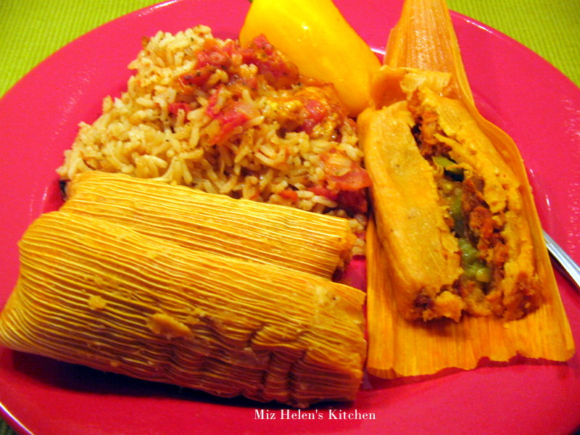For the Parisioners
Sun | Nov 9 | 8:00a M | (+)Rita Forsythe
 |  | 10:00a D | (+)Andrew Rodiger
 |  | 12:00p W | (+)George E. Coughlin
 |  | 2:00p D | (+)George e. Coughlin
Christmas Mass Schedule
Wednesday, December 24
6 p.m. Duncan Children's Mass
6 p.m. Walters
Midnight Mass in Duncan
Thursday, December 25
9 a.m. Marlow
11 a.m. Duncan
11 a.m. Ryan

FIRST FRIDAY ADORATION
ADORACIÓN _{DEL} 1er VIERNES
November 7

from 12:30 pm (after mass) - 3 p.m.
6 p.m. - 9 p.m.
Benediction will be from 9 pm
de 12:30 pm (después de misa) - 3 pm
6 p.m. - 9 p.m.
La Bendición será de 9 pm

Upcoming Events:
Thursday, Nov 6: 12:30 p.m., Altar Society Meeting, Assumption
Friday, Nov 7: First Friday Adoration
Sun, Nov 16: Children's Mass at 10 a.m.
Mon., Dec 8: Immaculate Conception Feast Day Mass, 7 p.m. in Marlow, one Mass only
Sat-Wed, Dec 6-10: Parish Advent Mission
Wed, Dec 10: 7 p.m. Penance Advent Service

You can have a Mass said for someone's intentions at their birthday, wedding, baptism, or in memory of your deceased loved ones. Contact he office for days and times that you wish to have the Mass celebrated. What a precious gift!

Abuse of Minors Pastoral Response Hotline 405-720-987 or DHS at 1-800-522-3511. Línea Telefónica Pastoral para Reportar Abuso de Menores 405-720-9878 o el Departamento de Servicios Humanos al 1-800-522-3511.

!!!Religious Education News!!!
1st-7th Grades, Wednesdays
6:00-7:15 p.m.
8th-12th Grades, Sundays
11:15 a.m. - 12:30 p.m.
Dates to Remember:
Wed, Nov 26: Thanksgiving Break, No R.E. Class
Sun, Nov 30: Thanksgiving Break, No R.E. Class
Dec 21-Jan 4: Christmas Holiday, No R.E. Classes
Altar Society News:
There will be an Altar Society Meeting
Thursday, November 6
after 12:10 Mass
in Gillespie Hall!!!
All Ladies of the Parish are Members
and encouraged to bring a dish to share
and a friend!

Anniversary Mass
Archbishop Coakley invites married couples who are celebrating milestone anniversaries (25, 40, 50+) in the calendar year 2014 to attend a special Anniversary Mass on Sunday, Nov. 16, at 3 p.m. at Our Lady of Perpetual Help Cathedral, 3214 North Lake Ave., (NW 32 & Western) Oklahoma City. A reception will follow. If you plan to attend, it is imperative that you contact the Office of Family Life at (405) 721-8944. The archbishop will be imparting his blessing, and the local Catholic community will rejoice in your example and commitment to the Sacrament of Marriage.

Misa Celebrando los Aniversarios 25, 40, 50+
El Arzobispo Pablo Coakley invita a las parejas casadas que estén celebrando su aniversario especial de (25, 40, 50+) el presente año 2014 para que asistan a una Misa Especial de Aniversario el domingo 16 de noviembre, 2014, iniciando a las 3 p.m. en la Catedral de Nuestra Señora del Perpetuo Socorro, 3214 North Lake Ave., (NW 32 y Western) en Oklahoma City. Después de la Misa habrá una recepción. Es muy importante que si usted desea asistir contacte a la Oficina de Vida Familiar al (405) 721-8944. El Arzobispo le dará su bendición y la comunidad local se alegrará en su ejemplo y compromiso al Sacramento de Matrimonio.



you'll be glad you did!
Rehearsals on Saturdays from 2:00-3:30 p.m. at Assumption of the Blessed Virgin Mary Church and Warm-ups on Sunday from 8:45-9:30 a.m.
Christmas Music Rehearsals:
Sundays: 11:05-12:15 a.m.

We pray the Chaplet of Divine Mercy and the Rosary
Monday through Friday
at 11:45 a.m.
before the 12:10 Mass.
Everyone is invited to
participate and
spend time with Jesus!

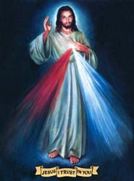

Baptismal Classes in English:
Sunday, December 14
after 8 a.m. Mass
in Immaculate Conception, Marlow
presented by Deacon Jimmy Conway

DUNCAN COLLECTIONs FOR oct 25-26:
Duncan: $1,960.39
Weekly Electronic Donations: $1,225.00
Building: Sanctuary Project: $525.00
Food Bank: $145.00
St Vincent de Paul: $225.00
Water for Life: $640.46
Ryan: $384.00
American Cancer Assn: $53.00
Thank you for your generosity!!!

Platicas del Sacramento de Bautizmo
en Español
Noviembre 8 Son a la 7 p.m. en La capilla.
Para mas informacioń
llame a la oficina
580-255-0590 ex 11,
o Carmen Garcia 580-255-6337 Gracias

Please remember your Parish in your will.

